Table of Contents
LIST OF TABLES iii
LIST OF FIGURES iv
CHAPTER 1: INTRODUCTION 1
1.1 Background 1
1.2 Rationale of the assignment 2
1.3 Objective and Scope of the Work 3
1.4 Expected outputs 4
1.5 Structure of the Report 4
CHAPTER 2: METHODOLOGY 6
2.1 Approach 6
2.2.1 General Approach 6
2.2.2 Technical Approach 7
2.2.3 Quality Management Approach 8
2.2.4 Participatory Planning approach 8
2.2 Methodology 9
2.3 Delivery of the report 12
CHAPTER 3: DESCRIPTION OF THE SYSTEM 14
3.1 Historical background 14
3.2 Study area 14
3.3 Headwork 16
3.4 Canal network 17
3.5 WUA structure 19
CHAPTER 4: UPDATE ON ASSET INVENTORY AND VALUATION OF THE ASSET 20
4.1 Summary on asset inventory 20
4.1.1 Canal Networks 20
4.1.2 Regulating structures 21
4.1.3 Service road 25
4.2 Valuation of the asset 27
4.2.1 System Infrastructure 27
4.2.2 Land 27
4.2.3 Buildings 28
4.2.4 Equipment 28
CHAPTER 5: ASSET MANAGEMENT PLAN 30
5.1 Irrigation System Maintenance 31
5.2 Types of Maintenance 31
5.3 Maintenance Problem and Solutions to be executed 35
5.4 Maintenance Tasks and Priorities 51
5.5 Maintenance Planning and Execution 54
4.2.5 Risk Assessment and Criticality assessment 54
5.6 Operation and Maintenance team, roles, responsibilities and procedure 56
CHAPTER 6: FINANCIAL PLAN 57
6.1 Existing System and Status of Collection 57
6.2 Assessment of Service Fee Requirement to Match the O & M Cost 57
6.3 Estimation of Annual O & M Costs 57
6.4 Deferred Maintenance Costs 63
6.5 Resource Management Plan 63
CHAPTER 7: CONCLUSIONS AND RECOMMENDATIONS 67

LIST OF TABLES
Table 1-1: Expected outcomes of the Report 4
Table 2-1 : Adopted Technical Approaches 7
Table 3-1 : Number of different structures in CNIS 15
Table 4-1: Canal details and respective discharge values 20
Table 4-2 : Inventory of Regulating structures in CNIS 23
Table 4-3 : Details of service roads of CNIS canals 26
Table 4-4 : Valuation of Land owned by CNIS 27
Table 4-5 : Rehab cost of Buildings owned by CNIS 28
Table 5-1 : Regular maintenance activities to be carried out 32
Table 5-2 : Periodic maintenance activities to be carried out 34
Table 5-3 : Types of canal problem, affected structure and number of structure affected. 36
Table 5-4 : Prioritization table of different maintenance types 51
Table 5-5 : Number of structures based on prioritization types 53
Table 5-6 : Risk table based on Impact and Probability values 54
Table 5-7 : Branchwise Risk score for individual structures 55
Table 6-1 : O & M costs under Headwork category 58
Table 6-2 : O & M costs under Main Canal category 58
Table 6-3 : O & M costs for Building, Equioment and Vehicles 59
Table 6-4 : Annual Operation cost for CNIS 59
Table 6-5 : Total O & M costs for Branches, Sub Branches and minors 61
Table 6-6 : Building, Equipment and Machineries cost for WUA 62
Table 6-7 : Annual Operation costs for WUA 62
Table 6-8 : Resource Mobilization Plan for WUA 65

LIST OF FIGURES
Figure 2-1 : Methodological Chart of AMP 9
Figure 3-1 : Location map of study area 16
Figure 3-2 : Headwork of Chandra canal irrigation system 17
Figure 3-3 : Canal Network Diagram of CNIS 18
Figure 3-4 : Canal Network diagram of CNIS 18
Figure 5-1 : Partially and fully destroyed structures in CNIS 39
Figure 5-2 : Structural cracks encountered in CNIS 42
Figure 5-3 : Erosion around canal structures 44
Figure 5-4 : Water seepage through gates leakage 45
Figure 5-5 : Weed and Vegetation growth in canal 48
Figure 5-6 : Excess debris in surrounding area of structures 49
Figure 5-7 : Clogged pipes of different structures 51
Figure 6-1 : Proposed Organizational chart of CNIS 59

CHAPTER 1: INTRODUCTION

Background
The Department of Water Resources and Irrigation (DWRI) is a government organization responsible for planning, developing, maintaining, operating, managing, and monitoring various environmentally sustainable and socially acceptable irrigation projects, both surface and groundwater, especially larger ones. Many of these systems are jointly managed by the DWRI and respective Water Users Associations (WUAs), but their performance has generally been below average. Efforts to enhance these systems performance through Participatory Irrigation Management or Irrigation Management Transfer have been made, but several factors still hinder their effectiveness.
Recognizing these challenges, the DWRI, through the Irrigation Management Division (IMD), has initiated a series of integrated action plans to improve irrigation system management, ensuring sustainable operation and increased efficiency. Recently, the DWRI developed Management, Operation, and Maintenance (MOM) guidelines, currently awaiting approval. These guidelines cover all critical aspects needed for the proper management of irrigation systems. One key component emphasized in the guidelines is the preparation and implementation of an Asset Management Plan (AMP) for the irrigation system.
In irrigation systems, assets include all infrastructure and equipment related to the system, such as canals, associated structures, water sources, canal right-of-ways, vegetation, buildings, and equipment. The guidelines define AMP as a process for sustainable maintenance planning, aimed at providing users with reliable and affordable irrigation services. A comprehensive and well-designed asset management framework offers numerous benefits, including improved irrigation system performance, better returns, enhanced cost efficiency, user satisfaction, and avoidance of performance failures.
Thus, the objective of the AMP is to outline a roadmap for the sustainable management and maintenance of irrigation canals and associated structures for optimal use by irrigation office and the local community. The AMP should include an asset survey to identify their physical and functional status, maintenance planning, implementation, monitoring, and quality control mechanisms. This study aims to clearly define all the significant aspects needed to prepare the Asset Management Plan for CNIS.

Rationale of the assignment
As a primarily agrarian nation, Nepal's economy heavily relies on agriculture, which constitutes over 35% of its GDP and employs more than 74% of its workforce. Consequently, the agriculture sector is prioritized by the nation, receiving significant resource allocation in each periodic plan. The vitality of the irrigation system directly affects agricultural productivity, which in turn drives economic growth.
The agricultural sector, contributing more than one-third of Nepal's GDP and serving as the primary source of employment, is essential for the livelihoods of its citizens. The expansion and efficient management of agriculture are imperative for increasing income levels, reducing poverty, and elevating living standards. However, the sector's performance has not kept pace with the rising food demand and livelihood requirements of the expanding population. Against the backdrop of recent global and national food crises and unprecedented spikes in food prices, the role of agriculture in mitigating food shortages remains crucial. Least developed countries, reliant on agriculture, aim to alleviate poverty and address economic challenges.
The Asset Management Plan (AMP) serves as a valuable tool in maximizing the performance and lifespan of irrigation assets by outlining strategies for regular maintenance, repairs, and upgrades. This optimization leads to improved water delivery efficiency, reduced downtime, and enhanced reliability of the irrigation system. An AMP enables the identification and mitigation of risks associated with asset defects of Irrigation system. By systematically assessing asset condition and performance, potential risks such as water distribution, infrastructure failures, or environmental impacts can be anticipated and addressed, reducing the likelihood of costly disruptions or accidents.
To address these challenges, the Department of Water Resources and Irrigation (DWRI) has initiated recommendations for the management, operation, and maintenance of irrigation systems to enhance overall performance. Recognizing that past management, operation, and maintenance actions were often ad hoc, DWRI aims to establish clear guidelines and a standardized strategy for creating MOM plans for each irrigation system. To expediently assess the system's status, DWRI has launched an asset management plan of the Chandra Nahar Irrigation System (CNIS).

Objective and Scope of the Work
The objective of this report is to prepare an Asset Management Plan (AMP) including the operation and maintenance plan of CNIS and the financial management plan of the Irrigation Office and WUA by conducting required surveys at the field level and by collecting available baseline data from concerned office and the Irrigation Management Division, DWRI, Jawalakhel.
In order to achieve the above objectives, the scope of the work for this assignment is, but not limited to:
- Collection and review of existing documents and literature regarding the assets, their physical conditions, operational status and needs to rehabilitate for their functionality;
- Evaluation of the key maintenance requirements and their associated cost for all the inventories of the CNIS. This assignment should at least cover a detailed survey at the structural level, design evaluation of hydraulic structures, and estimation of the maintenance cost of the assets.
- Preparation of the maintenance planning based on the class of maintenance, period of plan, cost estimate, schedule of work, method of execution, priorities of works and documentation for monitoring and evaluation. The prioritization of the works shall be based on the physical and functional condition of the structures in consultation with the WUA and field engineers.
- Preparation of the annual operation and maintenance cost, rehabilitation and improvement cost and emergency and deferred maintenance costs.
- Review of the organizational setup functions, procedures and reviews including human and financial resources
- Recommendation for the implementation arrangement of AMP at the Irrigation Management office and WUA. Preparation of action plan for implementation showing involvement of WUA and agency for different time frame;
- Analysis on the Irrigation service fee collections and other funding resources available for the operation and maintenance of the system;
- Analysis on the realization of the cost recovery of the system;

Expected outputs
Following outputs can be expected after the completion of this AMP;
Table 1-1: Expected outcomes of the Report
S.N. | Expected Outputs
1 | Condition assessment of Irrigation infrastructure and assets
2 | Maintenance tasks and Priorities
3 | Associated risk of individual assets and their immediate remedies
4 | Valuation of Assets
5 | Detail breakdown of the O & M cost of the system
6 | Financial plan

Structure of the Report
The findings are presented in the form of a report in two volumes.
The Volume I contain seven chapters. The contents of Volume I in each chapter are briefly described here under:
Chapter-1 Comprises of the introductory portion and highlights the study background, Rationale, scope and objectives of this study.
Chapter-2 Sheds light on the approach and methodology adopted in this study with the overall methodological framework.
Chapter-3 Describes Chandra Nahar Irrigation System (CNIS) overview with general characteristics of the system, headwork information, Canal networking and WUA structures.
Chapter-4 Comprises summary of asset inventory of the system with information regarding Canal, Regulating Structure, service road; valuation of the asset as well as Risk assessment and criticality assessment.
Chapter-5 Describes the maintenance type pertaining to the specific asset problem, prioritization of the maintenance problem and maintenance scheduling.
Chapter-6 Comprises the Institutional Development plan of the CNIS, which includes the proposed organizational plan of Irrigation agency and WUA; and all associated roles and responsibilities of O & M team.
Chapter-7 Comprises the Resource management plan, which includes the existing pattern of ISF collection, O & M cost estimation, deferred costs of the system and service fee assessment for matching O& M costs of the system.
Chapter-8 Comprises the Monitoring and Evaluation plan required for the execution of AMP in Chandra Nahar irrigation system.
Chapter-9 Summarizes the key conclusions and Recommendations of the study.
The Volume II of the report contains the Annexes as stated below:
Annex I: O & M cost calculations (Office and WUA part)
Annex II: Overall Inventory table (Includes Risk Score, Priorities of each structure of CNIS)
Annex III: Valuation of assets
Annex IV:

CHAPTER 2: APPROACH AND METHODOLOGY

Approach
This work primarily focuses on the AMP of an irrigation system, which requires technical, social, institutional and financial data. For information on the irrigation system related to Headwork, canals and command areas, previous reports on the Chandra Nahar irrigation system are obtained from the concerned authorities. Hydrological data are collected from DHM. The planning process should follow the normal steps of a technically effective, consultative and participatory approach and should include the following activities outlined below. Appropriate approaches and methodologies can only be developed after the key underlying issues in the provision of consulting services have been considered and understood.

General Approach
The Consultant has read the specific goal of the task and it’s ToR. The ToR is sufficient in and of itself for conducting the elements and procedures of selecting consultants, for making agreements regarding the stages of the works to be conducted, the methods of conducting the works, the standards of the works, the time constraints of the works, and the steps of payment.
We feel that process management should be the overarching strategy for the preparation of AMP of the Chandra Nahar irrigation system. This means that the Consultant's Team should hold consultations and collaborate closely with the client and other relevant stakeholders of the Chandra Nahar Irrigation project. The strategy calls for tight collaboration between the team and other directly and indirectly engaged organizations with Chandra Nahar irrigation.
Consultant suggests the general strategy listed below to complete the job. Based on a thorough understanding of the project objectives and the main underlying issues to be addressed when providing the services, the Consultant has established the approach and methodology. The consultant became knowledgeable with the project's elements, beneficiaries, strategy, and organization, as well as the project area. The Consultant has paid great attention to the RFP's service scopes that are listed in detail. With these as a foundation, the consultant plans to implement the envisioned strategy with a focus on the general strategies that are covered below:
- Selection of appropriate project personnel.
- Selection of successful methods
- Optimal combo of methods and technologies
- Close and effective coordination with concerned authorities
- Regular briefing of work progress
- Optimal use of available resources, maps and drawings
- Strict adherence to the work schedule
- Sufficient flexibility to respond to desired changes
- No compromise to the quality and standards
- Participatory approach;
- Consensus building
- Liaison with other sectoral interventions
- Maintaining transparency and accountability
- Commitment to quality and innovative thinking;
- Social equity and accessibility; and
- Holistic approach

Technical Approach
The Consultant will also draw on its extensive experience in providing consultancy services for AMP of the Chandra Nahar irrigation system. This is set to be accomplished using technical capabilities and public consultation skills side-by-side. The Consultant's technical approach shall comprise:
Table 2-1 : Adopted Technical Approaches
S.N. | Adopted Technical Approaches
1 | Preparation of efficient work plans for surveys and interviews
2 | Performing testing and quality control practices as per standards
3 | Full use of available reports, Maps, drawings and photographs
4 | Use of GPS, SW Maps and other work specifics for accurate data collection
5 | Use of Computer software accepted in case of Nepal like AutoCAD, GIS etc.

Quality Management Approach
We are committed to implementing internal quality assurance and control management systems in all operations being carried out for the proposed project based on concepts of globally recognized practices in order to achieve a high level of professional standard. In order to ensure that the QA System is implemented successfully, the consultant must define the roles and responsibilities of each party, as well as the methods and systematic management that must be used. Standards, measurement strategies, proper input and project verification, corrective action where necessary and other methods will be used to achieve this. The QA system will comprise, but not be limited to followings:
- The project coordinator and team leader will be made responsible for performing routine quality checks
- Ensuring each task within the study is undertaken by suitably qualified and appropriately experienced personnel
- Ensuring industry standards are adhered to in required surveys and designs
- Planning spot checks and supervision visits to cross-check the accuracy of surveys
- Referencing the sources of all standards, guidelines and information used
- Proper checking and approval of all the calculations, drawing and project reports

Participatory Planning Approach
The Consultant recognizes the vital role of Water User Associations (WUAs) in project success, committing to thorough consultation with local stakeholders. Guided by principles of inclusive participation, timely information access, two-way communication, and consensus building, the consultant will engage WUAs in planning and survey work. Regular coordination with the client ensures concerns are addressed promptly. Knowledge transfer is prioritized through interactions, on-the-job training, and technology exchange. An organized approach will navigate obstacles, fostering creativity among team members. Utilizing modern tools like GPS and GIS, spatial and temporal data will be collected and managed efficiently, enhancing project administration.

Methodology
The major objective of this task is the preparation of Asset management plan of Chandra Nahar Irrigation Project. Additionally, it emphasizes on the delivery of operation and maintenance plan of CNIS and its financial management plan. The Department of Water Resources and Irrigation (DWRI) has guidelines on Management, Operation and Maintenance (MOM) of Irrigation Systems, which include a comprehensive guideline for the preparation of the AMP. Asset Management Plan (AMP) for the Chandra Nahar irrigation system involves several key steps to ensure effective management and maintenance of assets. The following methodology outlines the process:
Figure 2-1 : Methodological Chart of AMP
Desk Study
Data Collection
Asset inventory & condition assessment
Risk Assessment & Criticality analysis
Risk Mitigation & cost analysis
Financial Planning
Development of O & M Strategies
Stakeholder Engagement & Contribution
Documentation & Reporting
Implementation & Monitoring

- Desk Study
The initial phase involves conducting thorough desk research on the Chandra Nahar irrigation system. Relevant materials from the Chandra Nahar Irrigation Project, gathered from DWRI, will be collected, reviewed, and analyzed. Additionally, journals, articles, and web resources related to the project will be accessed for comprehensive understanding. This cost-effective and efficient approach provides essential foundational knowledge for the project.
- Data collection
This is the second step of our task, which simply is the collection of all available resources, materials and information from various official sources that can be useful to our assigned task. These data can be in the form of maps, previous reports on the Chandra Nahar irrigation project, Asset inventory Report on CNIS, MOM guidelines, newspaper articles, maps, drawings and other aerial photographs. To become familiar with the study area, there is no substitute of data collection for deskwork and study. The various sources shall be used for the collection of secondary data some of which are:
- Previous progress reports and other reports on the Chandra Nahar irrigation project prepared by DWRI and other agencies.
- Annual audit reports
- Data related to irrigation service fee collection and the rates of each distributary.
- Information on WUA of Chandra Nahar Irrigation from Koshi pump Chandra Nahar Irrigation management office.
- Previous Asset Inventory reports and MoM guidelines
- Topo maps, District administrative map of District, Arial photographs and District Irrigation Map if available
- Digital GIS data Excel sheets relevant to irrigation network or irrigation area.
- Financial and technical Data regarding Chandra Nahar IS
- Other relevant reports
- Asset Inventory and Condition Assessment
In this step, a thorough inventory of all components encompassing the Chandra Nahar Irrigation infrastructure, encompassing canals, gates, structures, and control systems is done. The essential data regarding structure’s location, physical condition and performance is reviewed from the previous reports. However, as the condition might have deteriorated further or possibly improved (field condition may have changed, where previous report’s result is insufficient; the field work/survey/investigations are carried out. The condition of each asset in terms of functionality and structural stability is accessed in its present state.
- Risk Assessment and Criticality Analysis
After all field data are collected and verified, these structural data are subjected to potential risks and vulnerabilities associated with them, considering factors like failure likelihood, consequence of failure, and impact on system performance. The following formula can be used to estimate the level of risk.
Risk = Probability or chance that something happens x Effect or Impact when that happens
- Risk Mitigation and cost analysis
Once the risk associated with each asset is identified, the mitigation action to prevent or reduce these risks is identified. The roles are assigned to different authorities based on the technical and financial aspects of the mitigation work.
- Financial planning
Based on the cash flow analysis of the CNIS, its annual income and expenditure are estimated. Expenditure sheets associated with operation, maintenance and management are prepared separately whereas the income sheets from membership fees, donations and ISF are prepared. The Adjustment of Rates to be executed on the ISF per ha will be identified for counter balancing the O & M cost.
- Development of Operation and Maintenance Strategies
The smooth operation of an irrigation system is identified by the justifiable and dispute free distribution of irrigation water in the field (from Head to tail section). Thus, this shall be ensured by making operation strategies by optimization of various factors such as discharge rates, gate operation and irrigation frequencies.
The maintenance strategies for each asset category (Bridge type, Flow regulating type) will be prepared and the responsible authority (Farmers, WUA, Irrigation Office etc.) will be assigned considering factors like asset criticality, condition, and budget constraints. Furthermore, appropriate maintenance activities, frequencies, and methodologies, including preventive, routine, and Periodic maintenance approaches.
While operating the system, the application of the exact amount of water required by the crop at the right time is the main achievement and hence the farmers or operators need to know elements such as water discharge and rate, operating hours and irrigation frequency. Properly operated, maintained irrigation system and networks enable farmers to exercise absolute control over water use at farm level. Thus, it is easy for them to apply irrigation schedules based on crop, soil, weather, and water availability and quality factors.
There are two types of maintenance work for asset management i.e. preventive: done to keep the structures and canals in the desired condition, and Corrective: done after damage has occurred and it restores the system to the desired performance level. The well-known maintenance are as follows:
- Regular or Routine maintenance: It is preventive maintenance includes all small repairs work like greasing of gates, maintaining canal banks, small desilting, weed removing etc. on a regular basis throughout the year to keep the irrigation system functioning.
Table 2-2 : Regular maintenance activities to be carried out
Regular or Routine Maintenance
S.N. | Description
A | Embankment:  - Close holes made by rodents, snakes, crabs etc.  - Fill and compact depressed locations to the original bank level  - Repair side slopes to maintain the designed sections  - Fill up cracks or gullies formed on the top of the embankments  - Repair leakages by removing central core and replacing by compacted soil
B | Silt removal  - Remove silt in head regulator and measuring structures  - Desilt siphons, culverts, and bridges section for free passages of water  - Remove debris and trash from the inlet/outlet of siphons, head regulators, etc.
C | Vegetation removal  - Remove vegetation from canal lining joints  - Remove vegetation from foundation, walls of structures  - Remove vegetation in the canal and other structures for a clear water way  - Remove strong rooted plants from the embankments  - Trim branches of trees which grow towards the canal
D | Structural repair  - Make repair to small cracks in the masonry and concrete structures  - Repair small canal concrete lining works  - Repainting work on worn-out masonry structures  - Re-plastering for old worn out plastering works  - Repair small masonry or concrete structure damage
E | Greasing and Painting  - Greasing the moving parts of spindle screws, rollers on the gates  - Greasing the cables and drums of the barrage/main head regulators  - Greasing the gearbox systems of the gates  - Putting grease in the cups in the motors, generators etc.  - Remove old paint and rust by scrapping or sand blasting  - Repair the worn-out or rusted parts with primer  - Remove dust, and old grease before painting and applying new grease

- Seasonal maintenance: It needs to be done before and during the main cropping season and can be done during short closure of the canal. Work like major scouring of banks, breach of canal, major leaks in the canal etc. These are some preventive types and are temporarily made and in later stages may require periodic maintenance.
- Periodic maintenance: It is categorized as medium to large repairs and done on a periodic basis, annually or biannual or in certain intervals like 5 years etc. depending upon the necessity and funds available. Those works like repair and replacement of gates, repair of structures, repair or replacement of pumps etc. requires technical staff, need preparation and detailed planning, drawing, estimates, and close supervision during constructions. These types of maintenance work are corrective types and need long closure of the canal. Works like non-essential desilting, embankment repair or some structural repairs that are unlikely to deteriorate significantly after initial damage can be regarded as ‘’ deferred maintenance’’ and also includes those works which could not be completed in the previous year’s maintenance contract.
Table 2-3 : Periodic maintenance activities to be carried out
Periodic Maintenance
S.N. | Description
A | Intake Structure  - Repair to head regulators crests, stilling basin, abutments, piers etc.  - Repair to u/s and d/s floor protection works, concrete blocks, stone rip raps  - Replacement of gate plates, runners to prevent leakages  - Re painting of the gate sections under water which could not be done in regular maintenance  - Repair of stop logs and replacement if needed  - Replacement of worn-out water measuring gauges  - Major embankment work on flood protection work  - Major gabion work on the flood embankment and stone rip rap
B | Silt removal  - Remove large amounts of silt and debris from the canal.  - Repainting or remodeling of canal section to the designed section
C | Vegetation removal  - Remove large section trees and shrubs from canal section area  - Large scale control of aquatic and weed growth in the canal
D | Structural repair  - Major repair to masonry and concrete structures  - Major repair to canal concrete lining works
E | Embankment Repair  - Repair to embankment which is not covered in emergency maintenance  - Reconstruction of large section of embankment that is due to leakages, or slip, slope failures

- Emergency maintenance: It could be either preventive if not immediately repaired may cause serious damage and failure or corrective if not promptly undertaken may cause catastrophes to the canals or farmland. Emergency work should be carried out quickly so that safeguarding the structure is possible or canal operation is restored. Emergency works by its nature are undefined, but few works can be listed as below:
  - Riverbank or Canal Bank Breach
  - Structures Failures
Flooding

- Stakeholder Engagement and Consultation
The strategies to be developed from this AMP shall be discussed by getting engaged with key stakeholders, including water user associations, local communities, government agencies, and other relevant parties, throughout the AMP development process. Their input and feedback are incorporated in making the plan to ensure the primary needs, priorities, and expectations of the Chandra Nahar irrigation project.
- Documentation and Reporting
The AMP findings, recommendations, and implementation plans will be documented in a comprehensive report in A4 format. Clear, concise, and actionable information to facilitate decision-making and accountability will be included in the report. The mechanisms for ongoing monitoring, evaluation, and reporting to track progress and ensure continuous improvement.
- Implementation and Monitoring
AMP recommendations shall be implemented according to the established timelines and priorities. Moreover, asset performance monitoring, maintenance activities, and budget expenditures shall be carried out regularly to ensure compliance with the plan and achieve desired outcomes. The strategies and plans shall be adjusted as needed based on evolving conditions, new information, and feedback from stakeholders.
By following this methodology, the preparation of an Asset Management Plan for the Chandra Nahar irrigation system can help optimize asset performance, minimize risks, and enhance the overall efficiency and sustainability of the system.

Delivery of the report
The consultant needs to submit two copies of the inception and draft report, and five copies of final report after incorporating the comments from office including other related documents with compact disk of the report to the IMD, DWRI, Jawalakhel. The maximum time for the completion of the work will be Five months and it will be started from the day of agreement signed between the firm and Department of Water Resources and Irrigation.
The work schedule shall be as follows:
a) Completion of Inception Report – within 15 days after signing the contract
b) Completion of the Field Work – Within three months after signing the contract
c) Completion of the Draft Final Report – Within four months after signing of the contract
d) Completion of the Final Report – Within 10 days after receiving the comments on the draft report not exceeding six months of the total contract duration.

CHAPTER 3: DESCRIPTION OF THE SYSTEM

Historical background
The Chandra Canal, the first government-built irrigation system in Nepal, is situated on the right bank of the Triyuga River, which is a tributary of the Koshi River in Saptari District, was built in 1979 B.S. (1923 AD TO 1927 AD). The Government of India (GOI) provided funding for the project’s initial renovation. Subsequently, a pump canal, a distribution system, and another project for rehabilitating the Chandra Canal was implemented. The Chandra Canal Irrigation Project had an annual budget of only NRs. 1, 25,000 making it challenging to understand how such a substantial irrigation system could be operated within such constraints. Finally, the Indian government agreed to provide grant support for the aforementioned projects, including Chandra Canal rehabilitation. As a result, an Irrigation system was constructed, developed, and renovated to irrigate agricultural land in Saptari district, Nepal.

Study area
The Chandra Nahar Irrigation System (CNIS), Nepal's first planned irrigation system, was constructed nearly a century ago in the Saptari district of eastern Terai to provide water for agriculture. It marked the beginning of modern irrigation development in Nepal and has played a crucial role in the country's irrigation development since the introduction of periodic planning in 2013 B.S. The CNIS features a 28.6 km-long Chandra main canal with 12 branch canals, irrigating 12097 hectares of land. Due to its extensive canal network and large command areas, managing CNIS became a challenge. To address this, the government introduced a policy for joint management with Water User's Associations (WUAs). As a result, CNIS is now jointly managed by the Department of Water Resources and Irrigation (DWRI) and the WUAs.

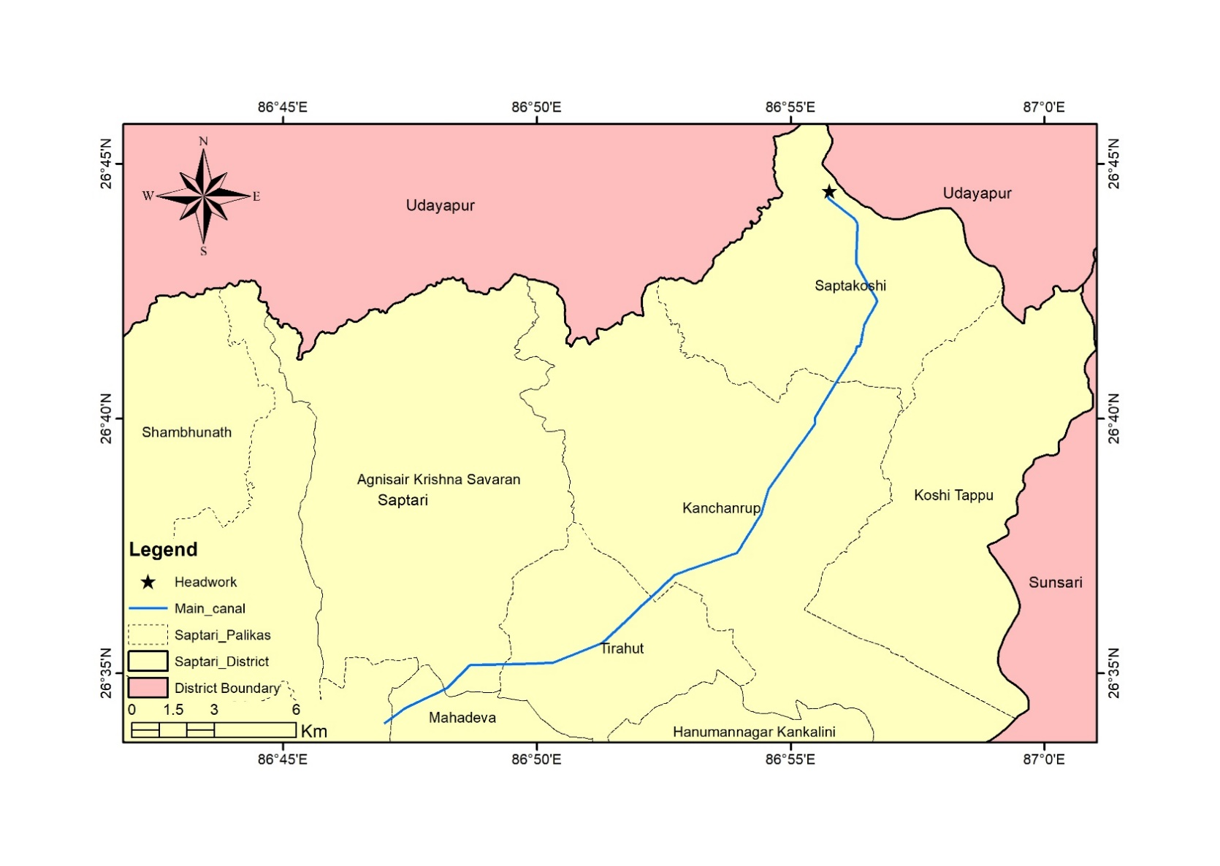
Figure 0-1 : Location map of the study area

Headwork
The head work of Chandra Canal Irrigation Project, located in Fattepur, Saptari District, is operating efficiently and remains in a stable condition. It was constructed using Bricks and Surkhi as a binding material and still functioning very well. However, the main canal, which receives water from headwork is experiencing significant silt deposition.
A concrete weir runs across the Triyuga River with a length of 312m and heavy silting and deposition is observed upstream of the weir. The intake structure contains 10 bays with a dimension of 3.5m for each bay. All gates are properly functioning, although they require cleaning, oiling, and greasing to ensure optimal performance.
Within the headwork of the CNIS, there is under-sluice structure with a partition, which is functioning well, except for the launching apron slab, which is significantly damaged and requires rehabilitation. The fish ladder, structurally, is in pleasing condition, but proper cleaning is required to maintain its functionality.
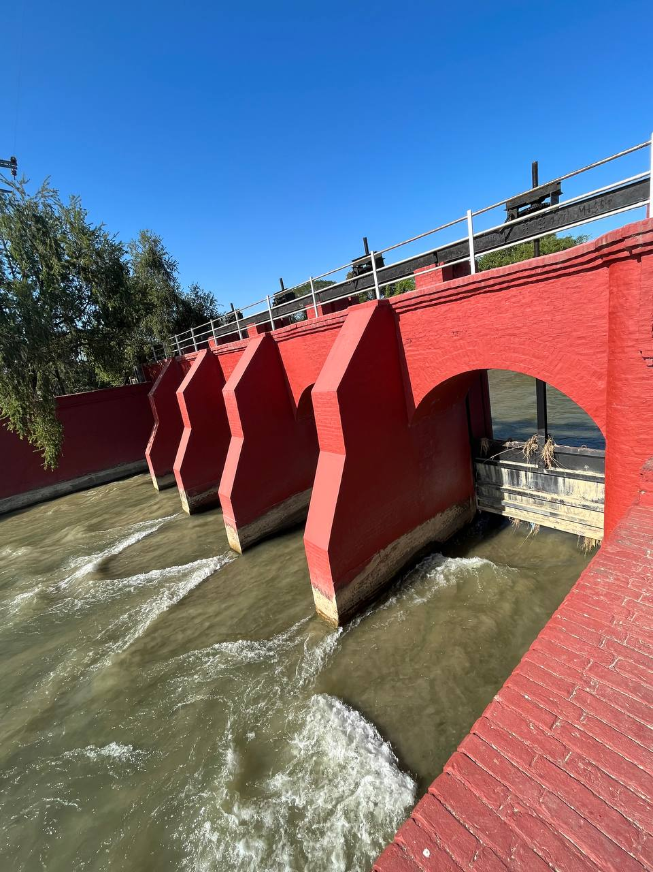
Figure 0-2 : Headwork of Chandra canal irrigation system

Canal network
The canal network of CNIS comprises of a 28.6 Km long main canal, 12 branch canals (distributaries), 2 branch canals and 2 number of minor canals. The Main canal is an earthen gravity flow contour canal, which begins at the headwork site in Fattepur and ends near the Khando River at Rajbiraj. It has a design capacity of 11.71 cumecs, which is the available water of the river during monsoon. The bed width of the main canal varies from 12m to 6m and the right bank of this canal is 2m wide whereas the left bank has 4m width. The Left bank serves as a service road for inspection and travel purposes for the office and villagers.
The 12 branch canal systems are characterized by having different canal capacities and command areas. These branch canals vary in their characteristics and infrastructure. Some of the branch canals have cross regulators, while some do not have. All the branch canals have head regulator to control the flow of water. Out of 12 branching canals, only six positions have cross regulators installed.
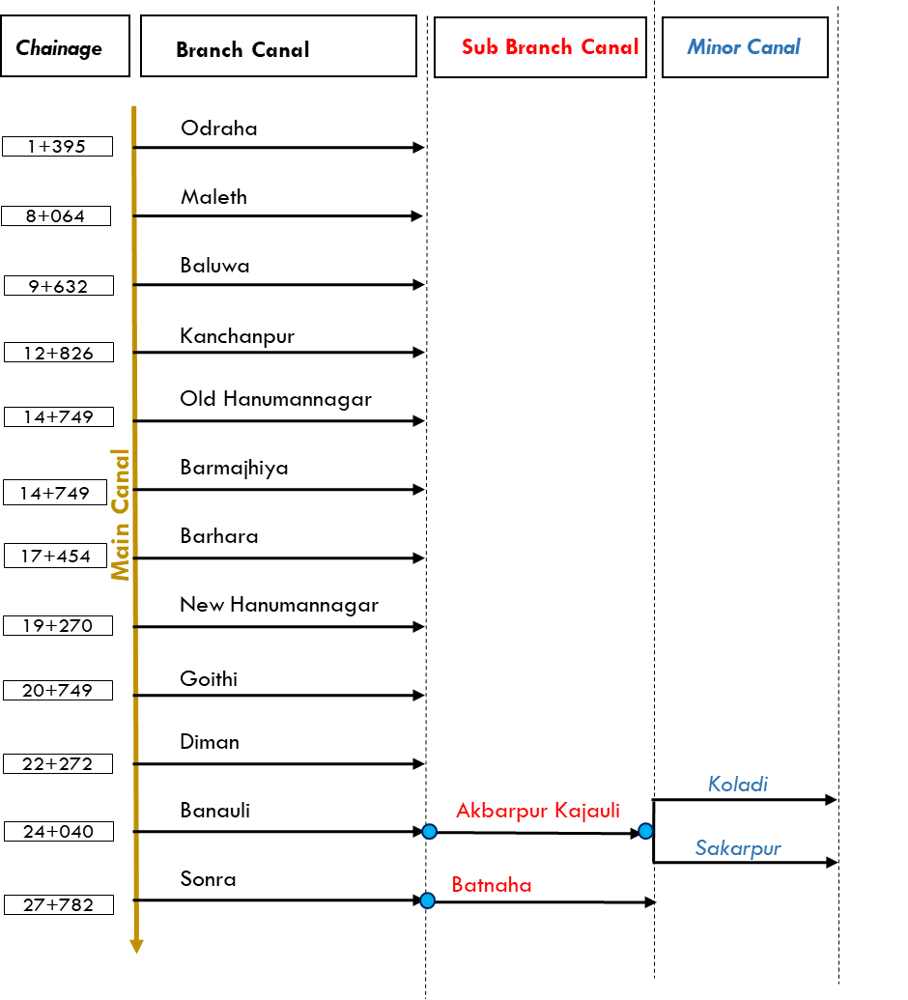
Figure 0-3 : Canal Network Diagram of CNIS

Figure 0-4 : Canal Network diagram of CNIS

WUA structure
The WUA coordination committee of CNIS was established and officially registered in the year 2055 BS under the Water Resources Act (1993). This committee is composed of a President, Vice President, Secretary, Treasurer, and 29 other members. Situated in Kanchanrup municipality, Kanchanpur, near the distributary, the WUA office actively engages in project planning, implementation, and ensuring the efficient operation of the irrigation system.
The annual general assembly, with 257 general members, is convened each year, and elections are conducted every four years. The same president is in charge of office since 2055 B.S. Adhering to WUA by-laws, the organization has ensured 33 percent female representation, with six female members actively participating in the committee. Remarkably, no gender discrimination in wage parity has been observed.
The WUA's primary responsibility is the collection of Irrigation Service Fee (ISF) from beneficiaries per cropping session, charging a nominal fee of 2 Rupees per kattha. The annual collection from the ISF for this irrigation system is estimated to be around one-lakh rupees.

CHAPTER 4: UPDATE ON ASSET INVENTORY AND RISK ASSESSMENT

Summary on asset inventory

Inventory of overall structures
Asset inventory report of CNIS suggested 670 structures of 22 different types. Among these structures, there are 103 village road bridges, 26 motor-able bridges, and 15 foot bridges. The total of 15 syphons and 25 Low Drainage (LD) syphon have been identified in the system. The system consists of 324 outlets that deliver water from the canal system on both sides to meet the irrigation water demand over the command area. Of these outlets, 207 are located on the left side of the canal, while the remaining outlets are on the right side. Furthermore, there are 17 drain inlets are for passing excessive water from the farmers’ fields into the canal system during monsoon season.
Five escape structures have been placed to release the excess water from the canal during flood or high flow and ensure the safety of the canal system. These structures for the release of excess water and provide an escape route in case of dysfunction or breaches downstream. Five number of aqueducts and one super passage are in the CNIS, which are in good condition.
Table 4-1 : Summarized table of asset inventory
S.N. | Canal Category | Canal Name | Cross Drain Structures |  |  |  | Flow Regulating Structures |  |  |  | Bridge Type |  |  | Other Structures |  |  |  |  | Total
 |  |  | Aq. | S.P | Sy. | LD Sy. | CR | HR | L.O | R.O | Br. | VRB | FB | Intake | S.E | D.I. | Esc. | Fall
1 | Main Canal | Main Canal | 3 | 1 | 8 | 8 | 6 | 11 | 47 | 3 | 4 | 24 | 5 | 1 | 1 | 10 | 4 | 1 | 137
2 | Branch Canal | Odraha | - | - | - | 1 | - | - | 19 | 16 | 1 | 9 | 1 | - | - | - | - | 7 | 54
3 | Branch Canal | Maleth | - | - | - | 1 | - | - | 4 | 2 | 1 | 3 | 1 | - | - | - | - | 3 | 15
4 | Branch Canal | Baluwa | - | - | 2 | - | - | - | 10 | 4 | 1 | 4 | - | - | - | 1 | - | 4 | 26
5 | Branch Canal | Kanchanpur | - | - | - | 1 | - | - | 8 | 6 | 1 | 3 | - | - | - | 2 | - | 8 | 29
6 | Branch Canal | Old Hanumannagar | - | - | 1 | - | - | - | 8 | 1 | 1 | 4 | 1 | - | - | 1 | - | 6 | 23
7 | Branch Canal | Barmajhiya | - | - | 1 | 4 | - | 1 | 16 | 3 | 1 | 11 | 1 | - | - | 1 | - | 7 | 46
8 | Branch Canal | Barhara | - | - | - | - | - | - | 1 | 4 | 1 | 1 | - | - | - | - | - | 2 | 9
9 | Branch Canal | New Hanumannagar | - | - | - | 4 | - | - | 18 | 19 | 2 | 11 | 2 | - | - | - | - | 12 | 68
10 | Branch Canal | Goithi | - | - | - | 1 | - | - | 9 | 7 | 2 | 3 | 1 | - | - | - | - | 7 | 30
11 | Branch Canal | Diman | - | - | - | - | - | - | 17 | 9 | 3 | 3 | - | - | - | - | - | 10 | 42
12 | Branch Canal | Banauli | - | - | - | - | 1 | - | 19 | 16 | 1 | 10 | - | - | - | - | - | 18 | 65
13 | Sub Branch | Akbarpur Kajauli | - | - | 3 | 4 | 2 | 1 | 7 | 6 | 2 | 5 | 2 | - | - | 1 | 1 | 1 | 35
14 | Minor | Koladi | - | - | - | 1 | - | 1 | 4 | 4 | - | 1 | - | - | - | - | - | 3 | 14
15 | Minor | Sakarpur | - | - | - | - | - | 1 | 3 | 2 | 3 | 1 | - | - | - | - | - | 3 | 13
16 | Branch Canal | Sonra | - | - | - | - | 1 | - | 11 | 9 | 1 | 7 | 1 | - | - | 1 | - | 9 | 40
17 | Sub Branch | Batnaha | 2 | - | - | - | - | 1 | 6 | 6 | 1 | 3 | - | - | - | - | - | 5 | 24
 | Total |  | 5 | 1 | 15 | 25 | 10 | 16 | 207 | 117 | 26 | 103 | 15 | 1 | 1 | 17 | 5 | 106 | 670

Aq. = Aqueduct CR =Cross Regulator VRB = Village Road Bridge RO = Right Outlet
S.P = Super Passage HR =Head Regulator FB = Foot Bridge Esc = Escape
Sy. = Syphon LO =Left Outlet S.E = Silt Excluder
LD Sy. = Low Drain Syphon Br. = Bridge D.I = Drain Inlet

Canal Networks

The CNIS irrigation network comprises of a main canal and 12 branch canals for contributing to effective water distribution. The Main Canal, with a length of 28.66 kilometers and a discharge of 11.71 cubic meters per second, serves as the primary channel for water distribution. Most of the section is unlined and has left bank as service road. There are12 Branch Canals (also referred as Distributaries) which separates from the main canal at different chainages, namely Odraha, Maleth, Baluwa, Kanchanpur, Old Hanumannagar, Barmajhiya, Barhara, New Hanumannagar, Goithi, Diman, and Banauli and sonra. These branches vary in lengths and water carrying capacities. Additionally, Banauli and Sonra branches are furthermore facilitated with Sub Branches namely Akbarpur Kajauli and Batnaha where the former sub branch is provided with two Minor canals. The longest branch in CNIS is the New Hanumannagar branch with a length of 7.19 Km while Barhara is the shortest canal of all with a length of 890 meters.
Table 4-2 : Canal details and respective discharge values
Canal Category | Canal Name | Length (Km) | Discharge (m³/s)
Main Canal | Main Canal | 28.66 | 11.71
Branch Canal | Odraha | 7.96 | 1.01
Branch Canal | Maleth | 1.33 | 0.17
Branch Canal | Baluwa | 2.41 | 0.50
Branch Canal | Kanchanpur | 3.04 | 0.30
Branch Canal | Old Hanumannagar | 3.54 | 1.17
Branch Canal | Barmajhiya | 4.80 | 0.16
Branch Canal | Barhara | 0.89 | 2.00
Branch Canal | New Hanumannagar | 7.16 | 2.00
Branch Canal | Goithi | 3.93 | 0.80
Branch Canal | Diman | 3.68 | 1.01
Branch Canal | Banauli | 4.60 | 1.75
Sub Branch | Akbarpur Kajauli | 4.70 | -
Minor | Koladi | 1.91 | -
Minor | Sakarpur | 1.40 | -
Branch Canal | Sonra | 4.71 | 1.13
Sub Branch | Batnaha | 3.02 | 0.07

System Rating
The performance ratings of various structures within the Chandra Nahar Irrigation System is included in Table 4-3 where the structures are divided into four categories. Each structure type is assessed based on a rating scale from 1 to 5, with higher ratings indicating better performance. For Cross Drain Structures, the Aqueduct has a total of 5 structures, with 80% receiving a rating of 3 or higher. The Super Passage and LD Syphon have 100% and 80% respectively in the same rating category. Syphon structures show strong performance with 93% rated 3 or higher. Among Flow Regulating Structures, Cross Regulators have 70% rated 3 or above, while Head Regulators and Outlet structures (L/s and R/s) exhibit high performance, with 81%, 90%, and 89% respectively. In the category of Other Structures, the Drain Inlet and Fall have high ratings of 88% and 96%, while Escape structures lag behind with only 60%. The single Intake and Silt Excluder structures show ratings of 100% and 0%, respectively. Bridge Type structures, including Foot Bridge and VRB, have 80% and 96% rated 3 or higher, indicating good performance in this category.
Table 4-3 : Rating Table
Category | Structure Type | Rating |  |  |  |  |  | % rating ≥ 3
 |  | 1 | 2 | 3 | 4 | 5 | Total
Cross Drain Structures | Aqueduct |  | 1 |  | 4 |  | 5 | 80
 | Super Passage |  |  |  | 1 |  | 1 | 100
 | Syphon |  | 1 | 2 | 12 |  | 15 | 93
 | LD Syphon | 2 | 3 | 1 | 19 |  | 25 | 80
Flow Regulating Structures | Cross Regulator | 3 |  | 1 | 6 |  | 10 | 70
 | Head Regulator | 1 | 2 | 10 | 3 |  | 16 | 81
 | Outlet L/s | 6 | 15 | 113 | 73 |  | 207 | 90
 | Outlet R/s | 2 | 11 | 60 | 44 |  | 117 | 89
Other Structures | Drain Inlet |  | 2 |  | 14 |  | 16 | 88
 | Escape |  | 2 | 1 | 2 |  | 5 | 60
 | Fall | 1 | 3 | 9 | 88 | 5 | 106 | 96
 | Intake |  |  |  |  | 1 | 1 | 100
 | Silt Excluder |  | 1 |  |  |  | 1 | 0
Bridge Type | Foot Bridge |  | 3 | 2 | 10 |  | 15 | 80
 | VRB | 3 | 1 | 21 | 72 | 6 | 103 | 96

Service road
The canal network of CNIS has the facility of service roads that serves its purpose of maintenance and access. The Main Canal has a service road on the left side, with a blacktopped and earthen surface in good condition, spanning a length of 25 kilometers. Notably, access road is available only after the Maleth Distributary. The majority of the canal sections are constructed with earthen material and are in good working condition, allowing for frequent vehicular movement.
Odraha Canal has service roads on both the left and right sides, with gravel type and in good condition, covering a distance of 7.96 kilometers. However, there are sections on the right bank where the road is absent. Maleth Canal has a service road on the left side, primarily earthen, with an average condition and a length of one kilometer. Baluwa Canal has an access road only up to midway, surfaced with earthen material and in poor condition, with a length of two kilometers. Kanchanpur Canal features an earthen access road throughout its 2.70 kilometers. Old Hanumannagar Canal has a service road on the left side, made of earthen and gravel, in good condition across its 3.54 kilometers. Barmajhiya Canal, with a service road on the left side and earthen type road, is in good condition but has one-kilometer road absent at tail section. Barhara Canal has a service road on right bank, having an earthen surface in poor condition, with a length of 0.89 kilometers. New Hanumannagar Canal boasts an access road throughout its 7.16 kilometers, surfaced with earthen and gravel and in good condition. Goithi Canal has an earthen access road, with about 900 meters of road absent along its 3 kilometers. Diman Canal features an earthen and gravel access road, with about 200 meters of road absent along its 3.5 kilometers. Banauli Canal has a gravel access road in good condition, covering its 4.6 kilometers. Akbarpur Kajauli Sub-Branch features an access road throughout its 4.7 kilometers, surfaced with earthen and gravel and in good condition. Both Koladi and Sakarpur Minors have earthen access roads in good condition, with lengths of 1.91 and 1.40 kilometers, respectively. Sonra Canal, with an access road surfaced with earthen and gravel, spans a length of 4.71 kilometers, and Batnaha Sub-Branch has an earthen and gravel access road in good condition, covering a distance of 3.02 kilometers. All these roads contribute to the efficient functioning and accessibility of the canal system.
To sum up, the service road for the all the branch canals were found to be in good condition, except Baluwa branch where the service road is deteriorated in various locations and been washed away. Urgent maintenance is needed for the Baluwa branch service road. Overall, the entire branch canal requires routine maintenance to ensure their functionality in the future.
Table 4-4 : Details of service roads of CNIS canals
S.N. | Canal Name | Service Road on |  |  | Road Type | Condition | Road Length (km) | Remarks
 |  | Left | Right | Both
1 | Main Canal | i |  |  | BT + E | Good | 25.00 | Access Road after Maleth Distributary
2 | Odraha | i | i | i | Gravel | Good | 7.96 | Road on right bank too in few sections
3 | Maleth | i |  |  | Earthen | Average | 1.00 | Last 200m road absent
4 | Baluwa | i |  |  | Earthen | Poor | 2.00 | Access road only up to midway
5 | Kanchanpur | i |  |  | Earthen | Average | 2.70 | Access road throughout
6 | Old Hanumannagar | i |  |  | E + G | Good | 3.54 | Access road throughout
7 | Barmajhiya | i |  |  | Earthen | Good | 3.80 | 1 Km road absent
8 | Barhara |  | i |  | Earthen | Poor | 0.89 | No service road
9 | New Hanumannagar | i |  |  | E + G | Good | 7.16 | Access road throughout
10 | Goithi | i |  |  | Earthen | Average | 3.00 | About 900m road is absent
11 | Diman | i |  |  | E + G | Average | 3.50 | About 200m road is absent
12 | Banauli | i |  |  | Gravel | Good | 4.60 | Access road throughout
13 | Akbarpur Kajauli | i |  |  | E + G | Good | 4.70 | Access road throughout
14 | Koladi | i |  |  | Earthen | Good | 1.91 | Access road throughout
15 | Sakarpur | i |  |  | Earthen | Good | 1.40 | Access road throughout
16 | Sonra | i |  |  | E + G | Good | 4.71 | Access road throughout
17 | Batnaha | i |  |  | E + G | Good | 3.02 | Access road throughout

(Note: BT = Black Topped, G = Gravel, E = Earthen Road)
(Source: Asset inventory Report of CNIS, 2023)

System Infrastructure
Following a consultation with the CNIS office and a field visit, it was found that the CNIS has an office building with a total area of 480 m² and a guest house of 225 m². Additionally, there are eleven staff quarters, each approximately 165 m². Of the five quarters located near the canal, the Fattehpur and Bhagwatpur quarters are non-functional, while the Maleth, Banauli, and Hanuman Nagar quarters are functional, each with an area of approximately 100 m². Table 4-5 shows system infrastructure with coverage area and their functionality.
Table 4-5 : Inventory of Buildings in CNIS
S.N | Building | Numbers | Unit Coverage (m²) | Total Area (m²) | Remarks
1 | Office building | 1 | 480 | 480 | Functional
2 | Guest house | 1 | 225 | 225 | Functional
3 | Staff quarter 1 | 1 | 165 | 165 | Functional
4 | Staff quarter 2 | 1 | 165 | 165 | Functional
5 | Staff quarter 3 | 1 | 165 | 165 | Functional
6 | Staff quarter 4 | 1 | 165 | 165 | Functional
7 | Staff quarter 5 | 1 | 165 | 165 | Functional
8 | Staff quarter 6 | 1 | 165 | 165 | Functional
9 | Staff quarter 7 | 1 | 165 | 165 | Functional
10 | Staff quarter 8 | 1 | 165 | 165 | Functional
11 | Staff quarter 9 | 1 | 165 | 165 | Functional
12 | Staff quarter 10 | 1 | 165 | 165 | Functional
13 | Staff quarter 11 | 1 | 165 | 165 | Functional
14 | Fattehpur Quarter | 1 | 100 | 100 | Non functional
15 | Maleth Quarter | 1 | 100 | 100 | Functional
16 | Banauli Quarter | 1 | 100 | 100 | Functional
17 | Bhagwatpur Quarter | 1 | 100 | 100 | Non functional
18 | Hanuman Nagar Quarter | 1 | 100 | 100 | Functional
(Source: Fieldwork, 2023)

Equipment
The list of equipment and its functionality has been collected from CNIS Office during the field visit. Major equipment with their number and functionality are listed in Table 4-6.

Table 4-6: Inventory of Equipment’s in CNIS
S.N | Goods Particulars | Number | Remarks
1 | Jeep | 3 | Operational
2 | Motorcycle | 4 | Operational
3 | Laptop | 4 | Operational
4 | Printer | 3 | Operational
5 | Projector | 1 | Operational
6 | Level Machine | 3 | Operational
7 | Desktop Computer set | 1 | Operational
8 | Tripod | 4 | Operational
9 | Invertor | 2 | Operational
10 | Photo copy Machine | 2 | Operational
(Source: Fieldwork, 2023)

Valuation of the asset

Land
The data on land owned by CNIS has been collected from CNIS office and in reference to district land rate of Saptari, the valuation of CNIS land has been estimated. Total valuation of CNIS land is about 53,47,12,750. The land value of each land with location name is shown in Table 4-7.
Table 4-7 : Valuation of Land owned by CNIS
S.N | Location | Number of Parcels | Bigha |  | Kattha |  | Dhur |  | Equivalent Hectare (Ha) |  | Land Rates  /Kattha |  | Land Valuation (Rs)
1 | Rajbiraj | 1 | 8 |  | 0 |  | 0 |  | 5.418 |  | 3300000 |  | 528000000
2 | Maleth | 1 | 0 |  | 7 |  | 0 |  | 0.237 |  | 82500 |  | 577500
3 | Hanumannagar | 1 | 0 |  | 5 |  | 5 |  | 0.178 |  | 385000 |  | 2021250
4 | Fattehpur | 1 | 0 |  | 4 |  | 10 |  | 0.152 |  | 550000 |  | 2475000
5 | Banauli | 1 | 0 |  | 1 |  | 5 |  | 0.042 |  | 550000 |  | 687500
6 | Bhagawtpur | 1 | 0 |  | 8 |  | 13 |  | 0.293 |  | 110000 |  | 951500
Total |  |  |  | 9 |  | 6 |  | 13 |  | 6.321 |  |  |  | 534712750
(Source: Fieldwork, 2023)

Buildings
Taking reference of AMP Report of Kankai Irrigation system, rehabilitation Cost of various type of building per square meter is considered .Total rehabilitation cost is estimated to be NRs. 6,515,625. The Table 4-5, present building detail with rehabilitation cost.
Table 4-8 : Rehab cost of Buildings owned by CNIS
Sn. | Building detail | No of floor | Length (m) | Breadth (m) | Covered Area of one unit | Total area (m2) | Rehabitation Cost (NRs.)/m2 | Rating | Total Rehabitation cost
A | CNIS BUILDING
1 | Main Office | 1 | 40 | 12 | 480 | 480 | 2500 | 4 | 1200000
2 | Guest house | 1 | 15 | 15 | 225 | 225 | 2000 | 3 | 450000
3 | Staff quarter 1 | 1 | 15 | 11 | 165 | 165 | 2000 | 4 | 330000
4 | Staff quarter 2 | 1 | 15 | 11 | 165 | 165 | 2000 | 3 | 330000
5 | Staff quarter 3 | 1 | 15 | 11 | 165 | 165 | 2000 | 3 | 330000
6 | Staff quarter 4 | 1 | 15 | 11 | 165 | 165 | 2000 | 3 | 330000
7 | Staff quarter 5 | 1 | 15 | 11 | 165 | 165 | 2000 | 4 | 330000
8 | Staff quarter 6 | 1 | 15 | 11 | 165 | 165 | 2000 | 4 | 330000
9 | Staff quarter 7 | 1 | 15 | 11 | 165 | 165 | 2000 | 4 | 330000
10 | Staff quarter 8 | 1 | 15 | 11 | 165 | 165 | 2000 | 4 | 330000
11 | Staff quarter 9 | 1 | 15 | 11 | 165 | 165 | 2000 | 4 | 330000
12 | Staff quarter 10 | 1 | 15 | 11 | 165 | 165 | 2000 | 4 | 330000
13 | Staff quarter 11 | 1 | 15 | 11 | 165 | 165 | 2000 | 3 | 330000
14 | Fattehpur Qtr. | 1 | 10 | 10 | 100 | 100 | 2000 | 1 | 200000
15 | Maleth Quarter | 1 | 10 | 10 | 100 | 100 | 2000 | 3 | 200000
16 | Banauli Quarter | 1 | 10 | 10 | 100 | 100 | 2000 | 4 | 200000
17 | Bhagwatpur Qtr. | 1 | 10 | 10 | 100 | 100 | 2000 | 1 | 200000
18 | Hanumannagar Qtr. | 1 | 10 | 10 | 100 | 100 | 2000 | 3 | 200000
19 | Temple | 1 | 10 | 10 | 100 | 100 | 2000 | 3 | 200000
20 | Compound Wall | 1 | 250 | 225 | 475 |  | 75 | 3 | 35625
 |  |  |  |  |  |  |  |  | 6515625
(Source: Fieldwork, 2023; AMP report Kankai Irrigation System)

Equipment
Table 4-9 represents the present worth of various goods and equipment in CNIS, highlighting a significant depreciation over time. The items, including jeeps, motorcycles, laptops, printers, projectors, and other equipment, originally totaled NRs. 14,440,000 but have depreciated to a present worth of NRs. 4,797,235. Depreciation rate of 20% was used for the calculation of Net Present Value (NPV), reflecting the reduced worth of the goods over their useful life. The detailed calculation is included in Volume II, Annex 3 of the report.
Table 4-9 : Present value of Equipment in CNIS
S.N | Goods Particulars | Number | Total Original Price (NRs.) | Present Worth (NRs.)
1 | Jeep | 3 | 12,000,000 | 3,932,160
2 | Motorcycle | 4 | 1,200,000 | 393,216
3 | Laptop | 4 | 440,000 | 180,224
4 | Printer | 3 | 150,000 | 61,440
5 | Projector | 1 | 100,000 | 40,960
6 | Level Machine | 3 | 300,000 | 98,304
7 | Desktop Computer set | 1 | 80,000 | 26,214
8 | Tripod | 4 | 60,000 | 19,661
9 | Invertor | 2 | 60,000 | 24,576
10 | Photo copy Machine | 2 | 50,000 | 20,480
 | Total |  | 14,440,000 | 4,797,235
(Source: Fieldwork, 2023)

Risk Assessment and Criticality Assessment
After asset inventory with criticality assessment was performed, a list of possible failures of each component with different reasons/causes why asset fails are listed. More important than the cause, the impact on the structural stability and water delivery will be, hence it is therefore important that one assess the risk of each failure separately. The following formula was used to estimate the level of risk.
The effect score was calculated by taking the average value of the Impact scores of each structure based on their Structural ability and water delivery scores. The Table 4-10 shows a column with four types of effects. If any structure goes defective but has hardly any effect on the Structural stability or water delivery, it will be given a score of one (non-critical). If this defect would result in a complete loss of functionality of the system in terms of water delivery or structural stability, it gets a score of four (critical).
The probability of failure was given for each structure from high to minimal with the respective scores from four to one. In the row below the table, the probability is assessed. A probability score of one is given if the risk of that part breaking down is very low, or minimal. If the part is very likely to break down a probability score of four is given. Scores 2 and 3 are in between. The final risk score is then calculated by taking the product of these two scores. Thus, the criticality assessment of each component to fail was estimated which is called risk assessment using the following formula.
Risk = Probability or chance that something happens x Effect or Impact when that happens
Table 4-10 : Risk table based on Impact and Probability values
Effect/Impact | 4. Total loss of functionality | 4 | 8 | 12 | 16
 | 3. Reduction in functionality of the system | 3 | 6 | 9 | 12
 | 2. Reduction of functionality of part of the system | 2 | 4 | 6 | 8
 | 1. Hardly any effect | 1 | 2 | 3 | 4
 |  | 1-Minimal | 2-Low | 3-Med | 4-High
 |  | Probability

Table 4-11 : Branch wise Risk score for individual structures
Canal Category | Canal Name | Risk Score
 |  | 1 | 4 | 6 | 8 | 9 | 12 | 16
Main Canal | Main Canal | 66 | 16 | 21 | 1 | 33
Branch Canal | Odraha | 23 | 9 | 7 |  | 15
Branch Canal | Maleth | 12 |  | 2 |  | 1
Branch Canal | Baluwa | 10 | 2 | 1 |  | 13
Branch Canal | Kanchanpur | 15 | 2 | 2 |  | 10
Branch Canal | Old Hanumannagar | 16 | 3 | 1 |  | 3
Branch Canal | Barmajhiya | 28 | 4 | 4 |  | 7 |  | 3
Branch Canal | Barhara | 5 |  |  |  | 4
Branch Canal | New Hanumannagar | 30 | 15 | 4 |  | 17 | 2
Branch Canal | Goithi | 14 | 9 | 1 |  | 4 |  | 2
Branch Canal | Diman | 19 | 9 | 2 |  | 8 | 2 | 2
Branch Canal | Banauli | 31 | 10 | 2 |  | 16 |  | 6
Sub Branch | Akbarpur Kajauli | 13 | 10 | 6 |  | 6
Minor | Koladi | 3 | 2 | 3 |  | 6
Minor | Sakarapur | 6 | 6 | 1
Branch Canal | Sonra | 23 | 6 | 5 |  | 6
Sub Branch | Batnaha | 13 | 6 | 3 |  | 2
Grand Total |  | 327 | 109 | 65 | 1 | 151 | 4 | 13

Among the various risk scores obtained by these irrigation structures of CNIS, 13 structures obtained the highest vulnerability with a risk score of 16, indicating significant potential hazards that demand immediate attention and various mitigation strategies discussed in earlier sections. Following closely behind is segment with a risk score ranging from nine to 12, highlighting notable risks in the structures that require proactive measures to prevent adverse consequences. Risk score of eight exhibits a moderate risk level, emphasizing the need for vigilance and maintenance to ensure uninterrupted irrigation operations. Risk score below six, signals to a relatively stable condition but still requiring periodic assessment.

CHAPTER 5: MAINTENANCE PLANNING
Maintenance planning of any irrigation system is a critical process that ensures the long-term functionality and efficiency of the infrastructure. A systematic approach is to be developed in CNIS for identifying, scheduling, and implementing maintenance activities that keep the system in optimal condition. This includes regular inspections to assess the physical and operational status of Main canals, distributaries, pumps, regulating gates, and other structures, as well as timely repairs and replacements of worn or damaged parts. Effective maintenance planning also incorporates preventive measures to address potential issues before they escalate into major problems, thereby reducing downtime and avoiding costly emergency repairs. By integrating comprehensive asset management practices, including the use of advanced technologies, maintenance planning not only enhances the reliability and performance of Chandra nahar irrigation system but also maximizes the return on investment and ensures the sustainability of water resources for agricultural use.

Irrigation System Maintenance
Effective irrigation system maintenance aims to ensure the optimal functioning and longevity of irrigation infrastructure while maximizing water efficiency and minimizing environmental impact. Key objectives include regular inspection of components such as pipes, Regulating Gates, and Outlets to identify leaks, clogs, weed and vegetation growth or damage that could impede water flow or distribution. Cleaning and clearing of debris from outlets and gates are essential to maintain system efficiency. Calibration of equipment such as control gates ensures accurate scheduling and water application, preventing over- or under-irrigation. Additionally, monitoring soil moisture levels helps adjust irrigation schedules based on crop water requirement and environmental conditions, promoting water conservation and crop yield.
Overall, comprehensive maintenance efforts of an Irrigation system aim to optimize water use efficiency, promote sustainable resource management, and preserve the integrity of the irrigation infrastructure.

Maintenance Problem and Solutions
The maintenance activities are grouped according to the major problem of the Chandra Nahar irrigation system. The major problem categorization is listed in Table 5-1, which shows the types of canal problems, affected canal structure and the number of structures affected at Chandra Nahar Canal. Following problems are dealt in the structures of CNIS.
- Structure Partially or fully destroyed
- Structural Cracks
- Erosion around canal system
- Water seepage through gates, leakage problems
- Vegetation growth
- Excess debris, trash and scouring in surrounding area
- Clogged Pipe or destroyed pipe
Table 5-1 : Types of canal problem, affected structure and number of structure affected.
S.no. | Types of Problem | Structures Affected | Number
1 | Structure Partially or fully destroyed | Bridge, Outlet, Fall, Syphon, Drain Inlet | 242
2 | Structural Cracks | Bridge, Fall, Outlet, Drain inlet, VRB | 14
3 | Erosion around canal system | Outlet, Syphon | 22
4 | Water seepage through gates leakage | Outlet | 1
5 | Vegetation growth | HR, Outlet, Syphon, Drain Inlet, VRB, Fall | 42
6 | Excess debris, trash and scouring in surrounding area | Syphon, Fall | 9
7 | Clogged Pipe and destroyed pipe | Outlet, Drain inlet | 13
Total |  |  | 343

- Problem 1: Structure Partially or fully destroyed
Number of Problems encountered 242
Possible effect: The bridge structure may collapse, posing a risk of accidents and obstructing canal water supply due to damage to the bridge parapet wall. The damaged sidewall outlet is unable to channel water to the required field, resulting in water loss to undesired areas. Additionally, the damage to the crest wall of the fall may disrupt water supply regulation and lead to erosion. The failure of the syphon can further obstruct the water flow.
Priority: High
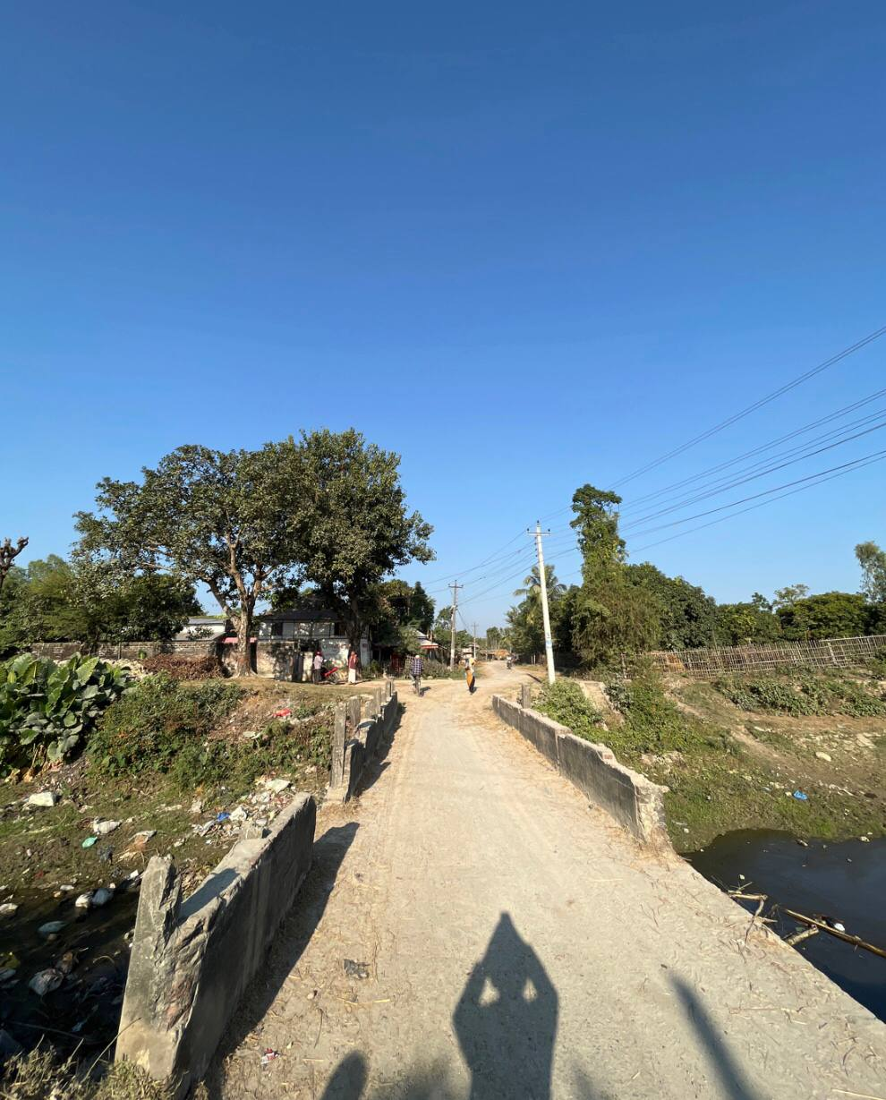  VRB partially damaged parapets  (Photo ID.: MC052) | 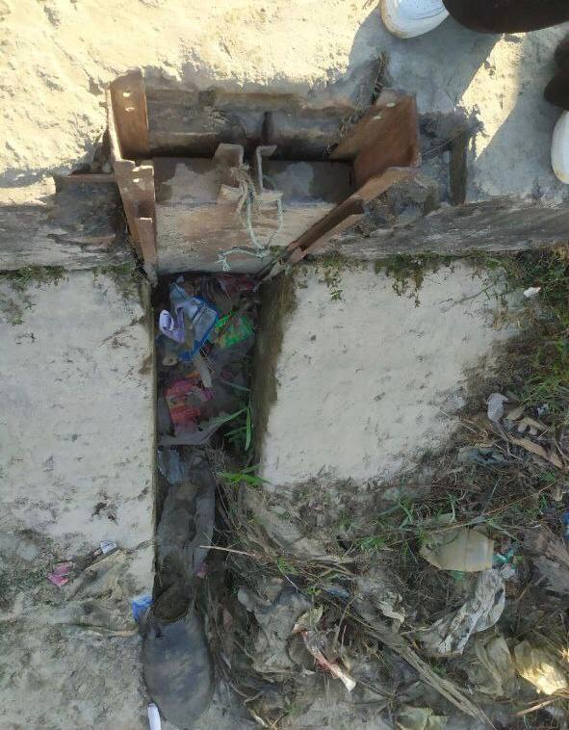  Left Outlet Gate Damaged  (Photo ID: OB033)
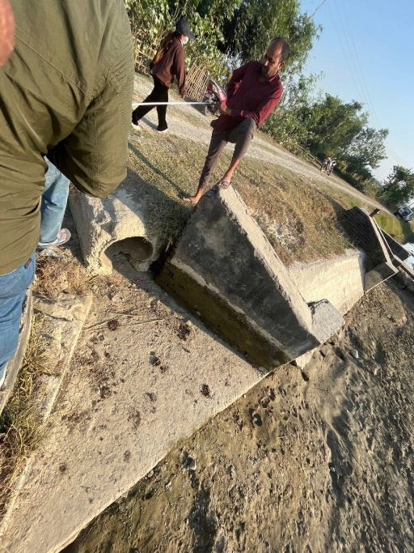  Left Outlet Side wall destroyed  (Photo ID: NH012) | 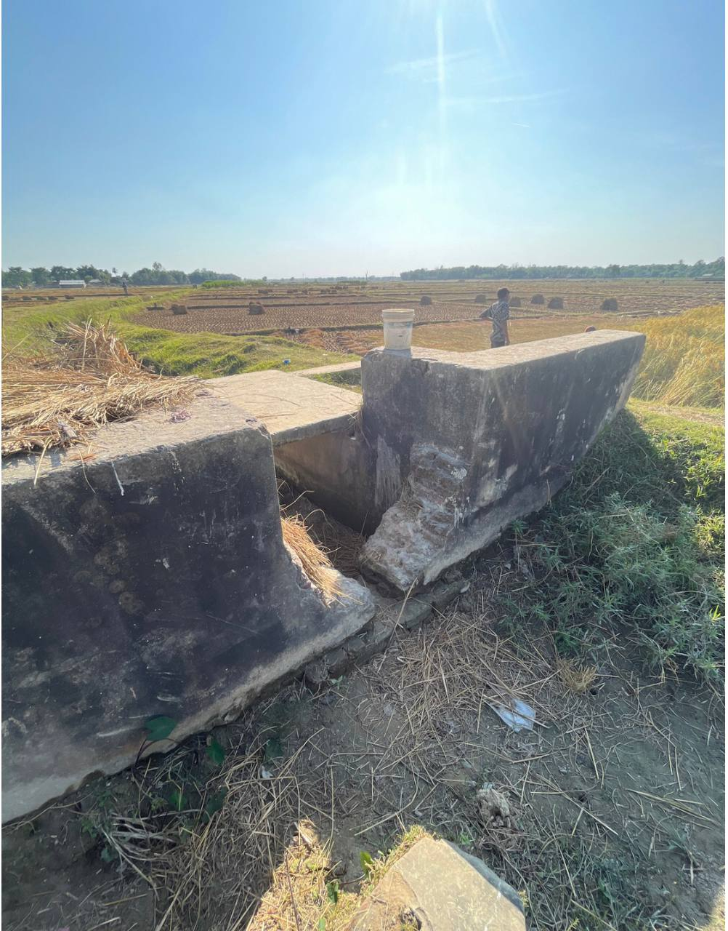  Fall Crest wall destroyed  (Photo ID: GB030)
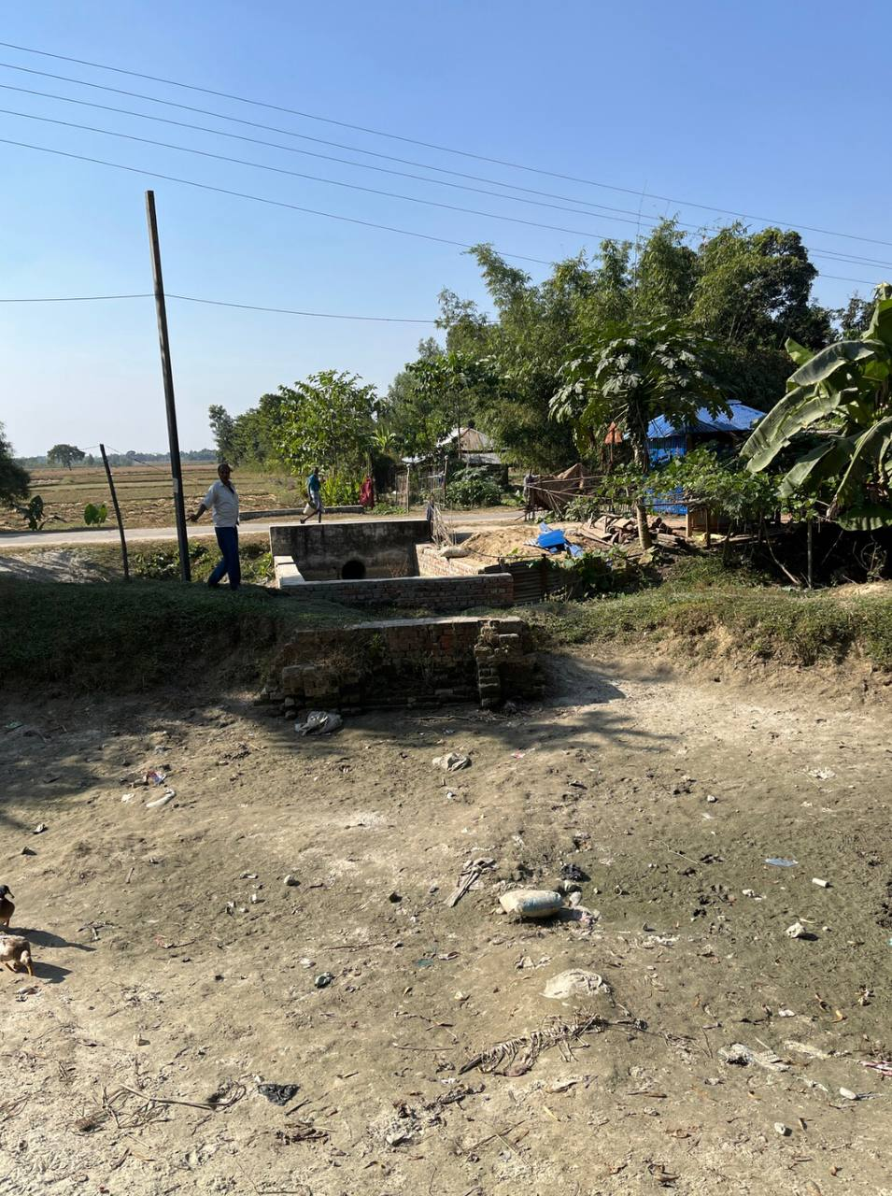  Right Outlet Completely destroyed  (Photo ID: BN011) | 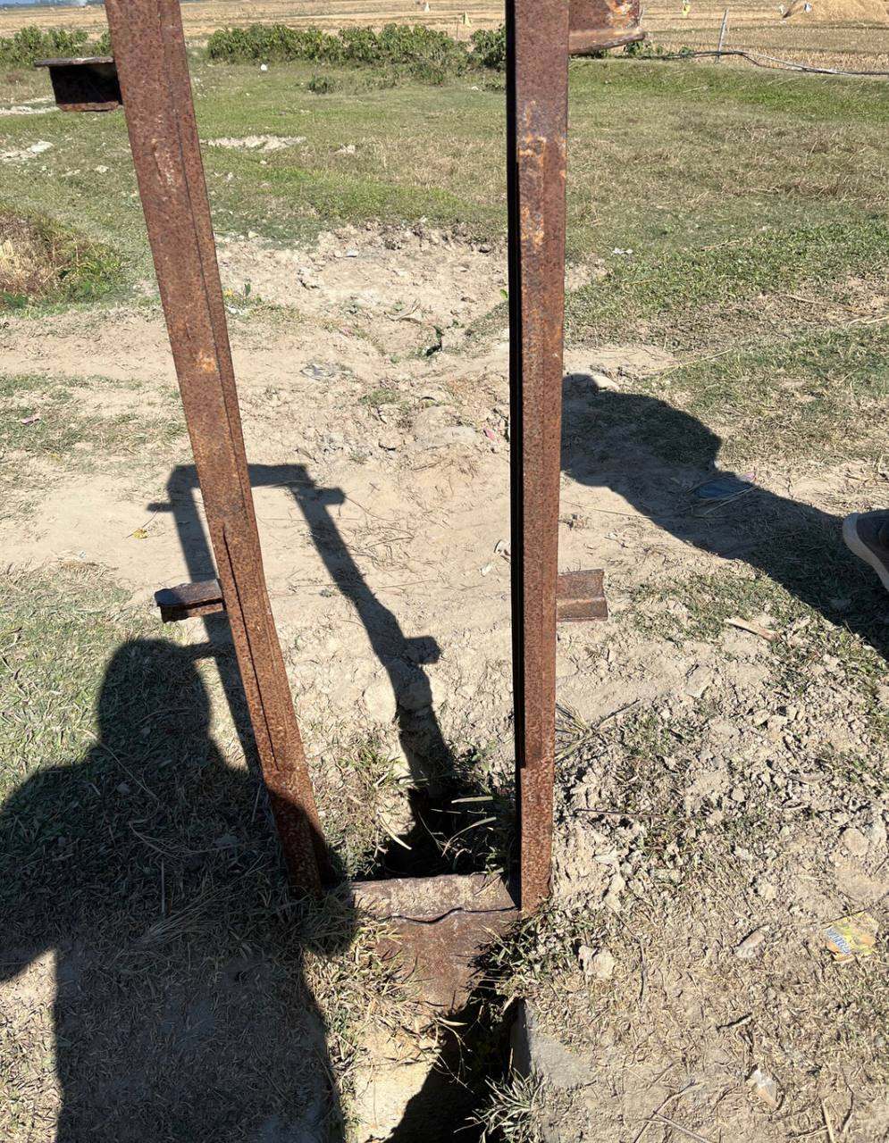  Left Outlet Gate Damaged  (Photo ID: KB019)
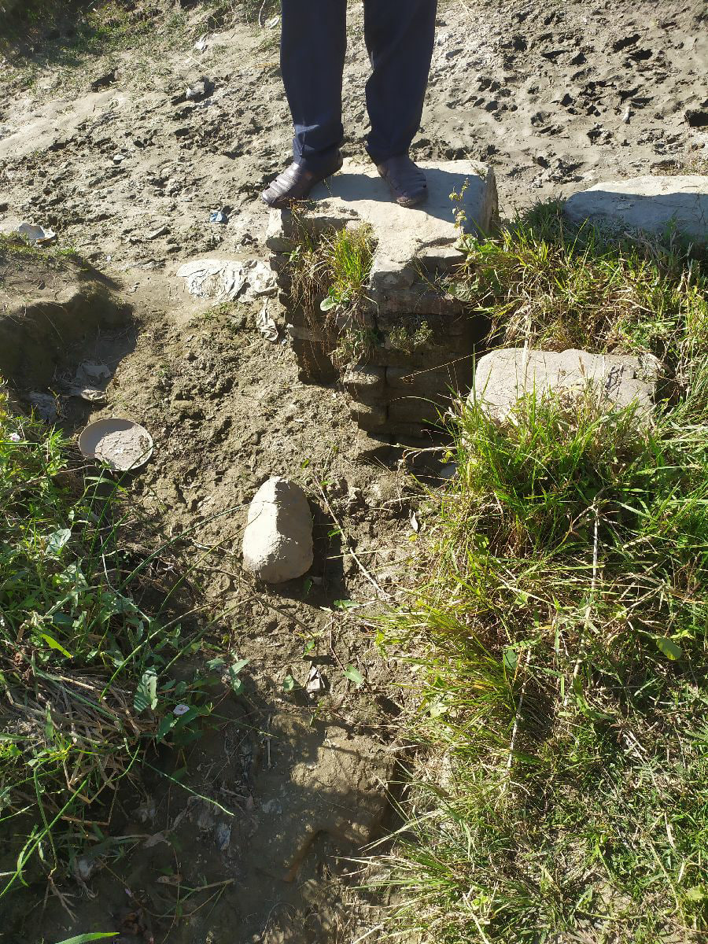  Left Outlet Outlet washed away  (Photo ID: BB014) | 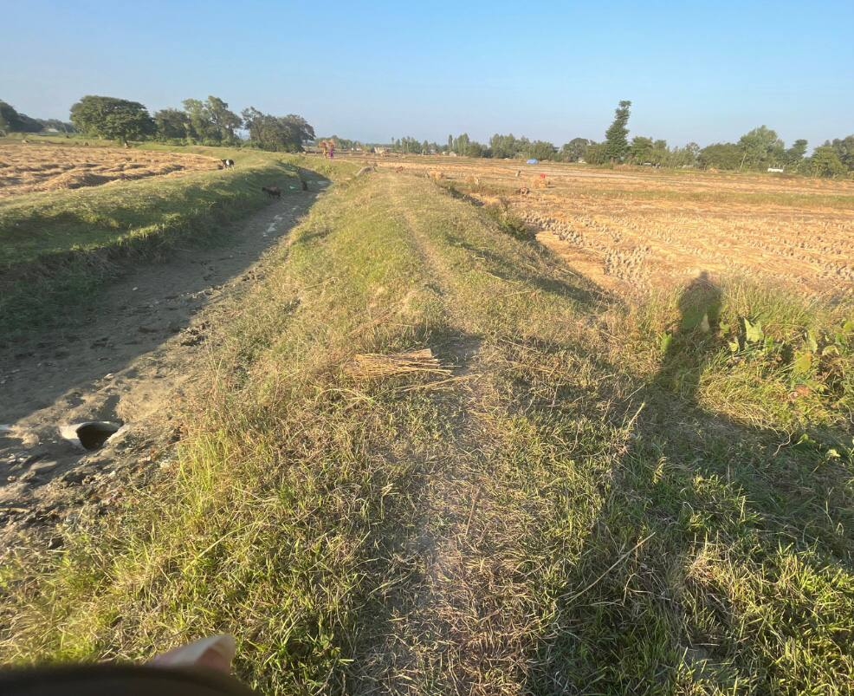  LD Syphon damaged pipe  (Photo ID: DM007)
Figure 5-1 : Partially and fully destroyed structures in CNIS
Solution: The structure should be filled and strengthened as soon as posible and a full repairment shall be carried out. Temporary measure (Sandbags and stakes etc) can be implemented in the meantime, but are not permanent solution. Close monitoring is a necessity until full repairs are completed. The repair process should involve the construction of new components such as the outlet, crest wall, parapet wall, and replacement of gates.
Types: Annual/Seasonal Maintenance.
- Problem 2: Structure Crack
Number of Problems encountered: 14
Possible effects: Small cracks in the canal structure pose a significant threat as they can rapidly diminish effectiveness and entail a high risk of failure, potentially leading to severe consequences for both human life and the economy. These cracks may result in the obstruction of water supply, causing overflow or unregulated flow. Addressing and repairing these cracks is essential to maintain the structural integrity of the canal, ensuring the safe and efficient conveyance of water while mitigating the potential for adverse impacts on both the environment and infrastructure.
Priority: High to medium

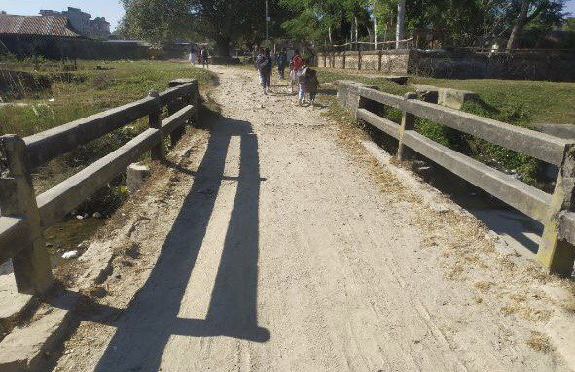  VRB Structural Cracks Main Canal (Photo ID: MC005) | 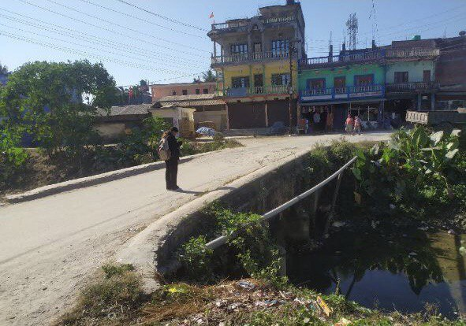  VRB Structural Cracks Main Canal  (Photo ID: MC006)
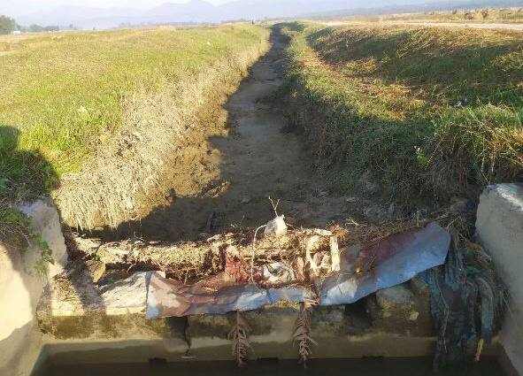  Fall Structural cracks  (Photo ID: OB012) | 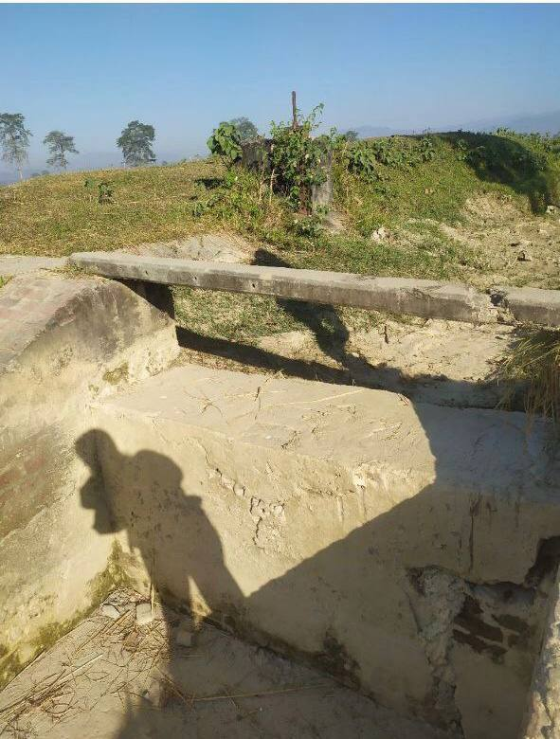  Fall Structural cracks Odraha  (Photo ID: OB041)
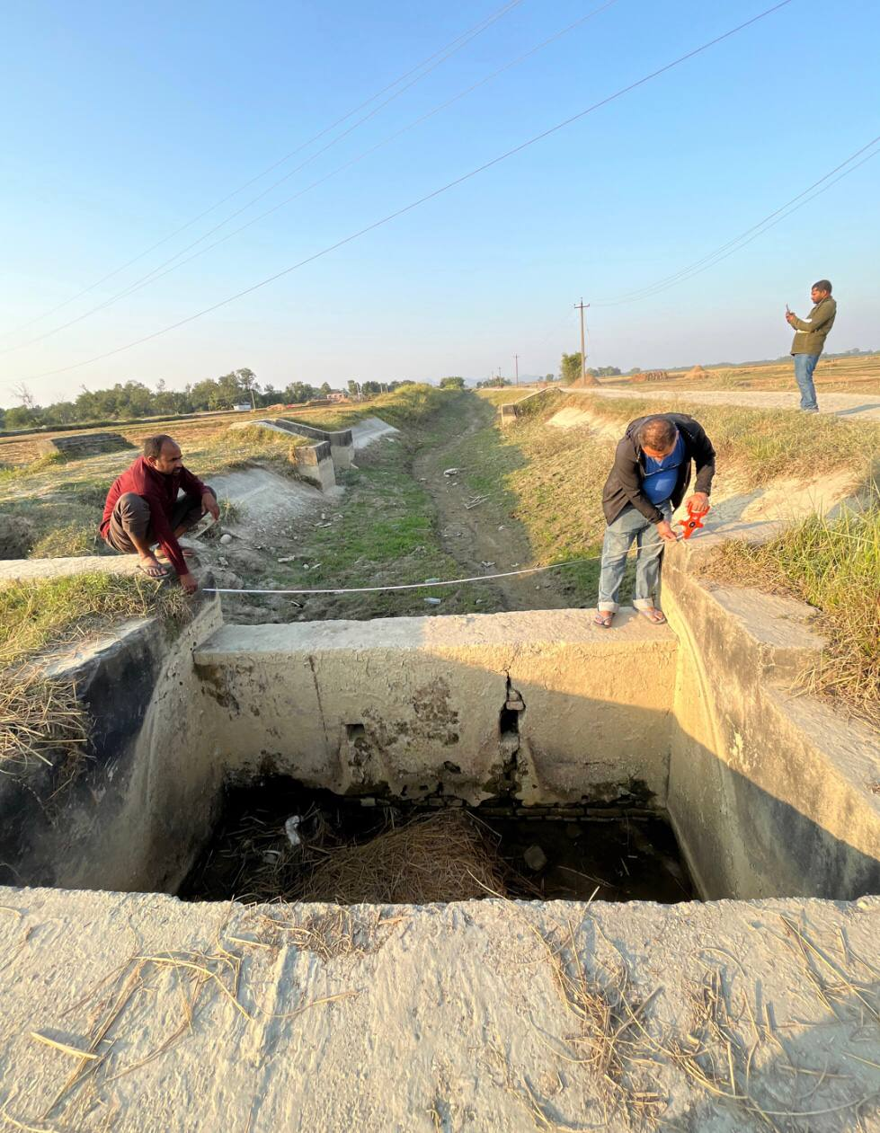  Fall Structural Cracks  (Photo ID: NH018) | 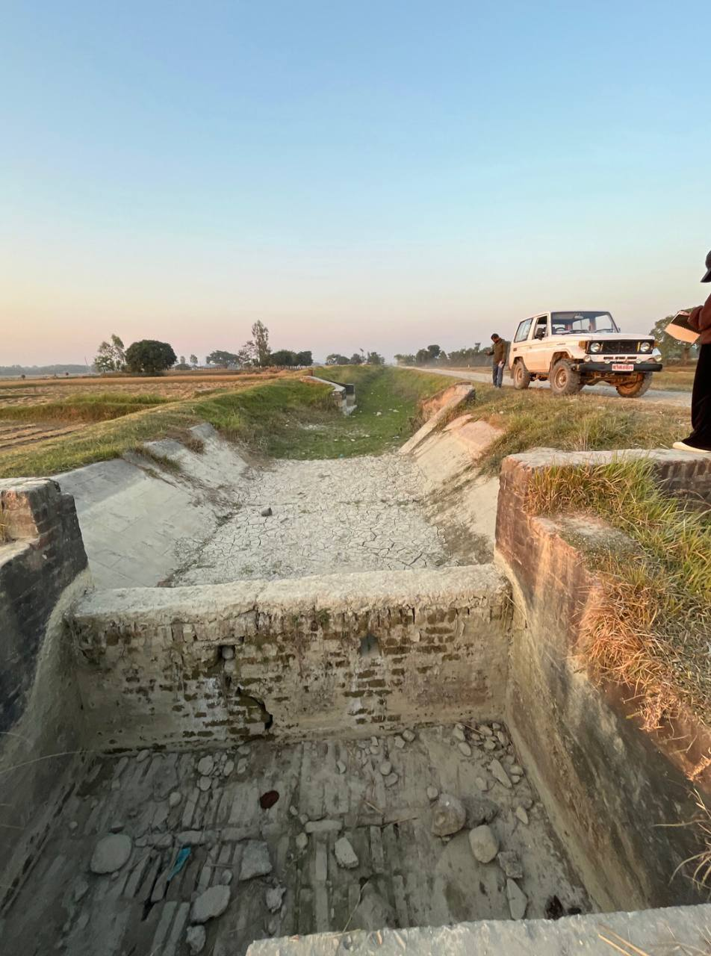  Fall Hanuman Nagar Structural Cracks (Photo ID: NH042)
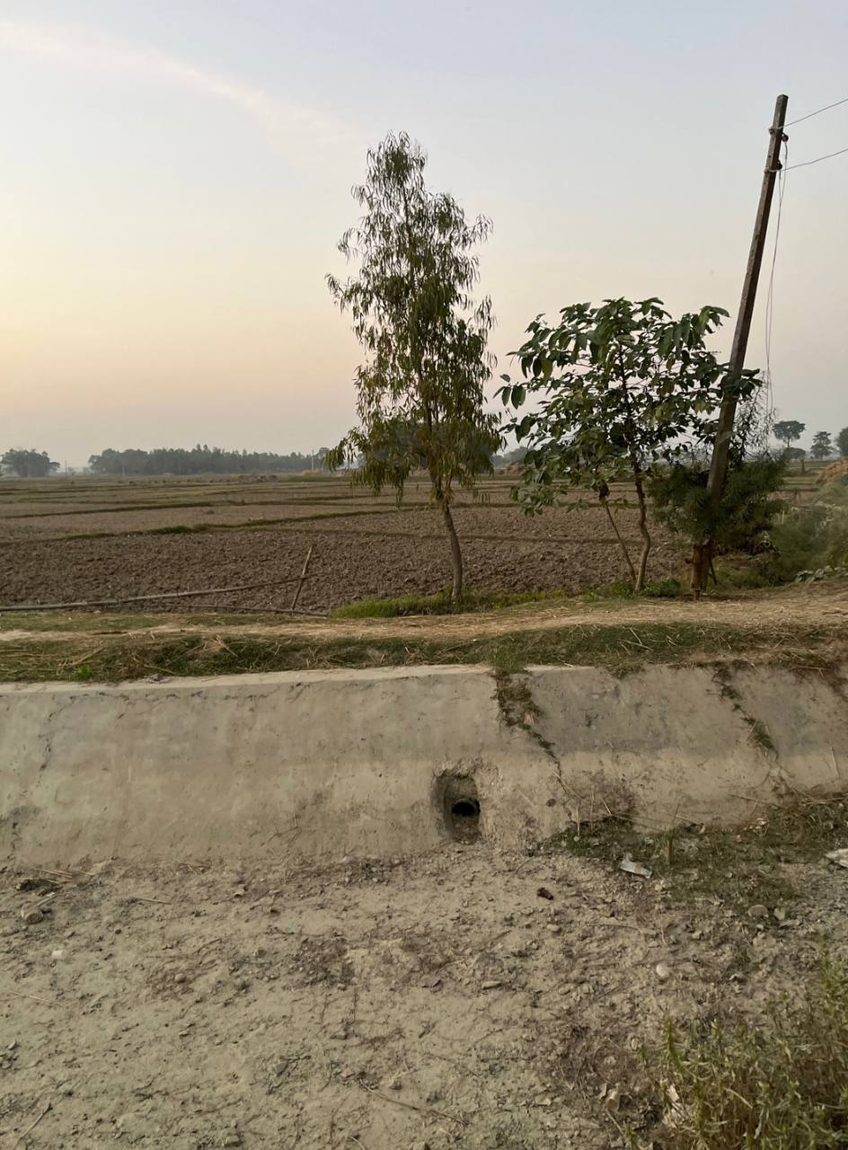  Right Outlet crack  (Photo ID: AK008) | 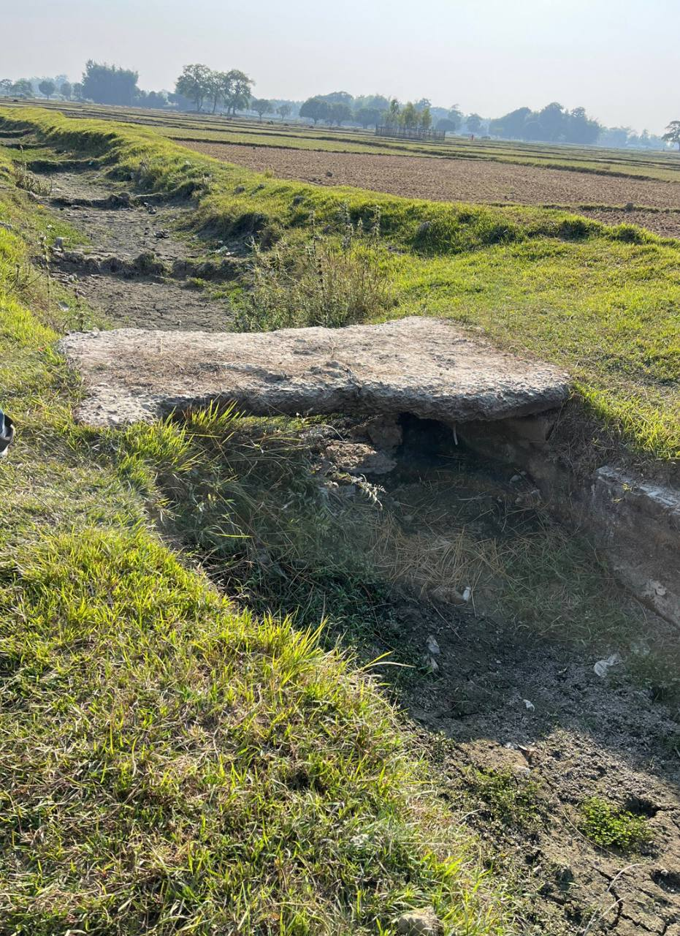  Foot Bridge structure crack  (Photo ID: AK035)
Figure 5-2 : Structural cracks encountered in CNIS
Solution: For the maintenance of structural cracks in a canal system, a viable solution involves thorough inspection and timely repair. Small cracks should be sealed with durable mortar to prevent further deterioration. Routine monitoring and immediate attention to any emerging issues are crucial. Additionally, implementing effective vegetation control measures along canal banks can minimize the risk of cracks during seasonal maintenance. A proactive approach to crack repair and overall maintenance ensures the longevity and optimal performance of the canal system. Regular inspections prompt repairs, and preventive measures contribute to the sustained functionality and structural integrity of the canal.
Types: Routine Maintenance.
- Problem 3: Erosion around canal structure
Erosion around canal system: 22
Possible effect: Erosion around a canal structure can lead to structural instability, causing potential collapse and loss of land. It may result in sedimentation within the canal, reducing water-carrying capacity and impact on water quality. The process can disrupt water supply, affecting agriculture and leading to environmental degradation. Effective erosion control measures are essential to prevent these adverse consequences and ensure the sustained functionality of the canal system.
Priority: High to Medium
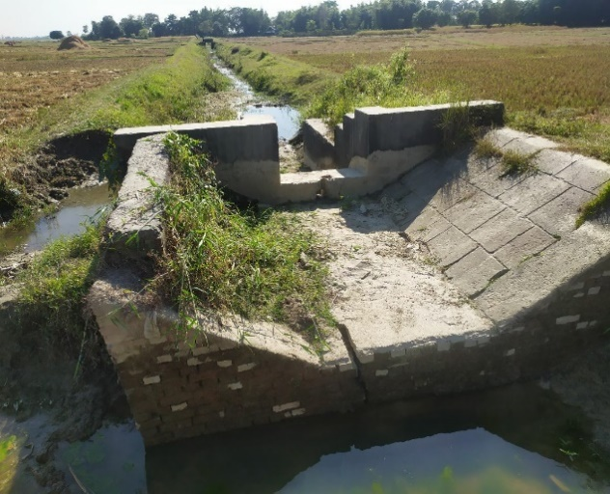  Fall Cracks and bank erosion  (Photo ID: BB017) | 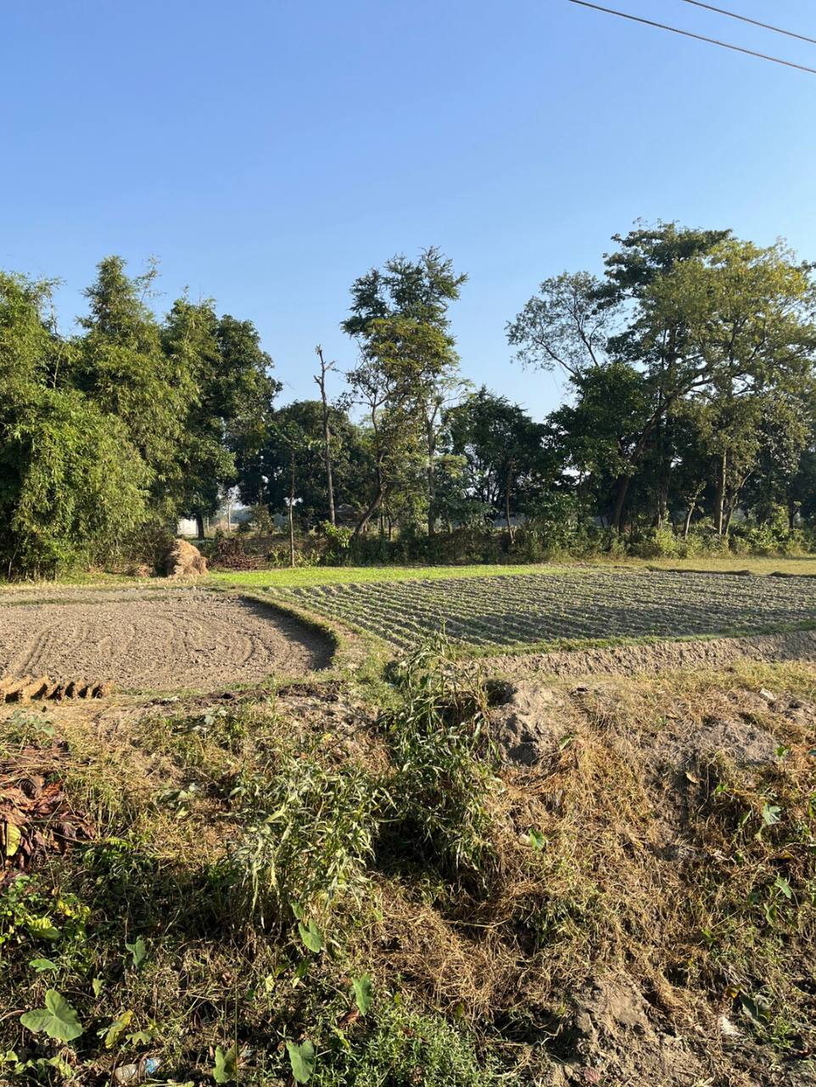  Left Outlet Bank erosion  (Photo ID: BR003)
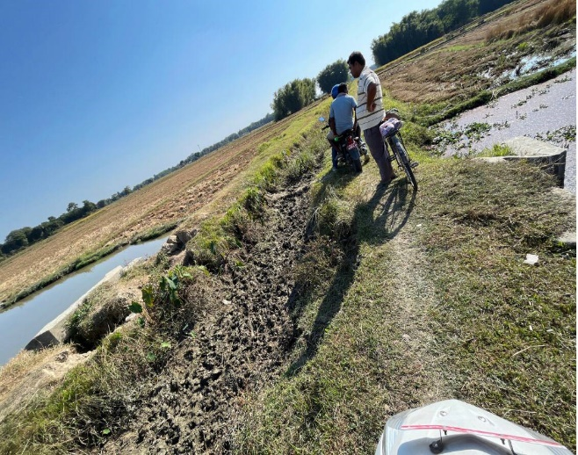  LD Syphon Bank erosion  (Photo ID: GB020) | 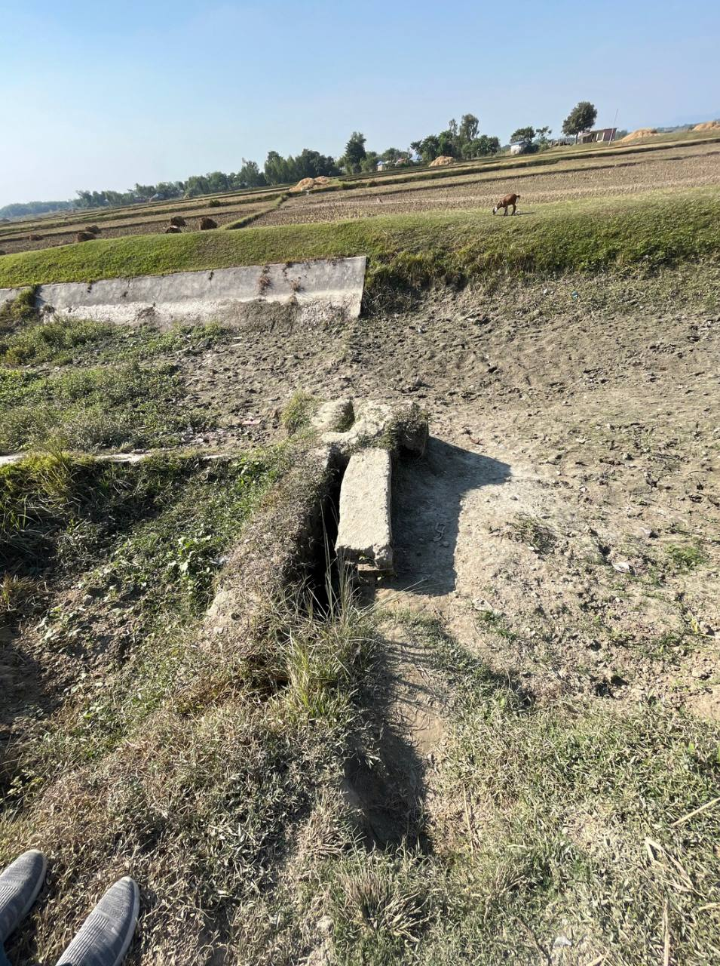  Missing gate and bank erosion  (Photo ID: BN019)

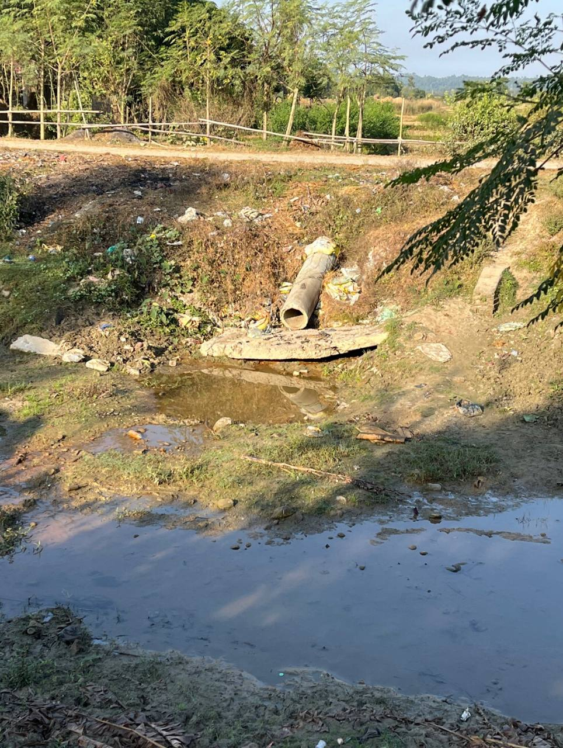  Erosion in surrounding area  (Photo ID: MC047) | 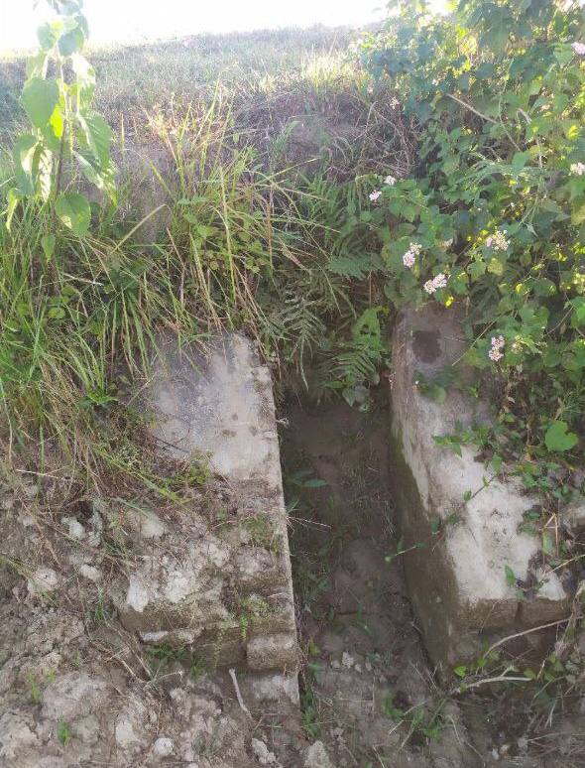  Erosion in surrounding area  (Photo ID: OB027)
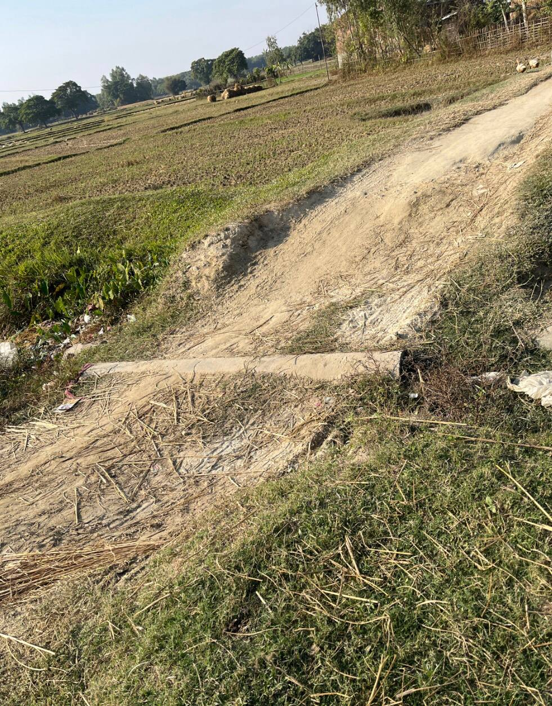  Erosion in surrounding area  (Photo ID: AK025) | 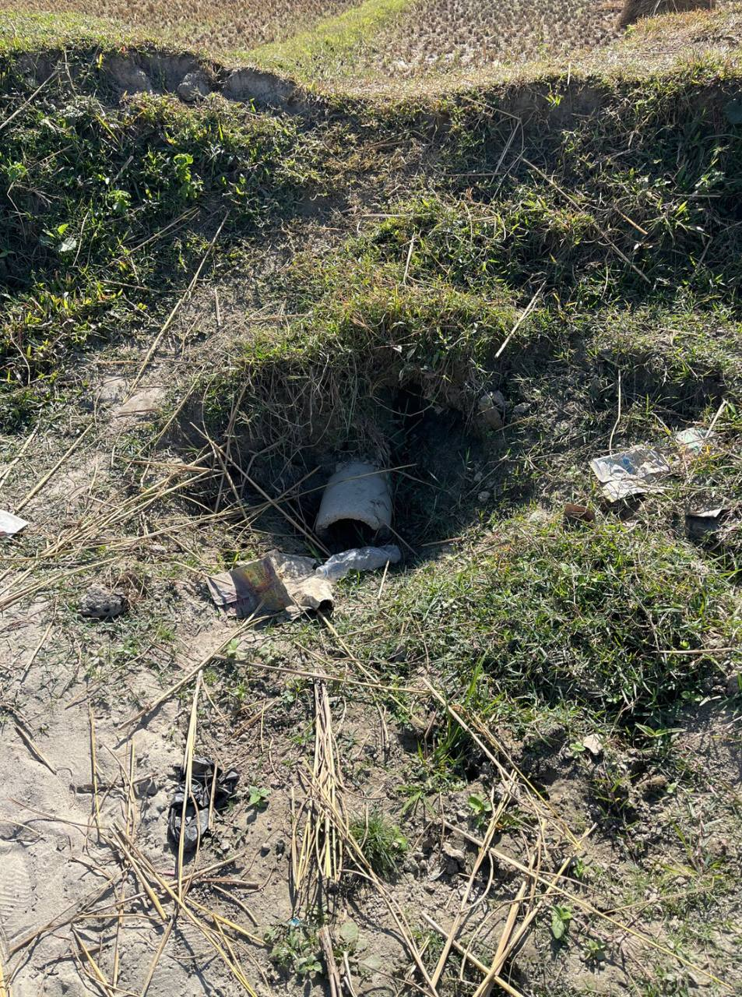  Right Outlet, Scouring in the vicinity
Figure 5-3 : Erosion around canal structures
Solution: Vegetative cover, such as grass and other erosion-resistant plants, can be established along canal banks to stabilize the soil and reduce erosion. Installing erosion control structures, like riprap or gabions, headwall can provide additional stability. Regular maintenance of these measures is essential, including repairing damaged vegetation and checking the reliability of erosion control structures.
Types: Annual/Seasonal maintenance

- Problem 4: Water seepage through gates leakage
Number of Problems encountered: 1
Possible Effect: Water seepage through gate leakage in a canal structure can result in significant water loss, compromising the efficiency of water distribution for irrigation and other purposes. This seepage may lead to structural instability, land subsidence, increased maintenance costs and erosion of the downstream canal bed and banks.
Priority: High to Medium
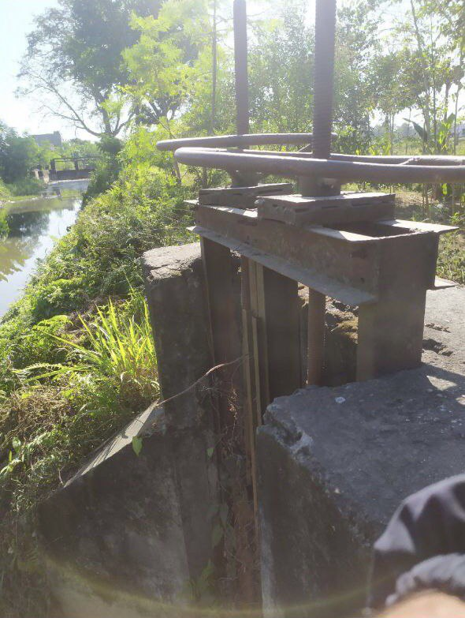  Water seepage through gate  (Photo ID: MC009) | 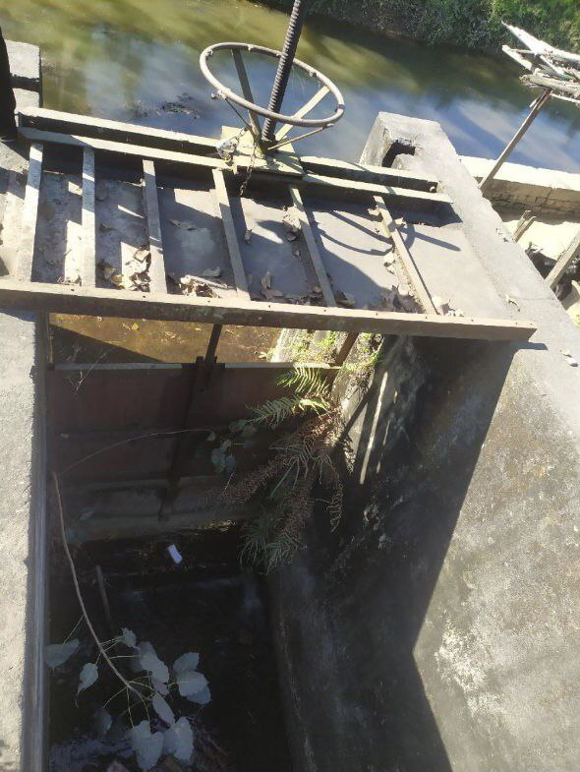  Water seepage through gate  (Photo ID: MC010)
Figure 5-4 : Water seepage through gates leakage
Solution: The solution and maintenance for water seepage through gates leakage in a canal structure involve prompt identification of leaks, immediate repairs, and routine maintenance of gate components, including hinges and seals. Implementing advanced gate technologies, such as automated systems with effective sealing mechanisms, along with regular vegetation management and sediment removal, is essential. Proactive monitoring systems can detect and address leaks in real-time. This comprehensive approach ensures the reduction of water seepage risks and maintains the integrity and efficiency of the canal structure.
Types: Annual/Seasonal maintenance.
- Problem 5: Weeds growth in canal
Number of Problems encountered: 42

Possible Effects: Weeds growth in a canal system can lead to several adverse effects, including obstruction of water flow, increased sedimentation, and reduced water-carrying capacity. The presence of weeds hinders efficient water distribution, potentially causing flooding in surrounding areas. Moreover, weed roots can weaken canal banks, contributing to erosion and structural instability. The accumulation of debris from decaying weeds may degrade water quality, impacting ecosystems and downstream users. Timely and effective weed control measures are crucial to mitigate these negative effects and maintain the optimal functionality of the canal system.
Priority: medium to High (Depending on location along canal and severity)
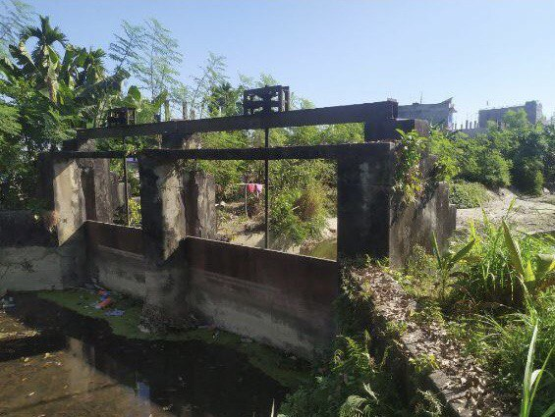  Head Regulator, Vegetation growth  (Photo ID: MC011) | 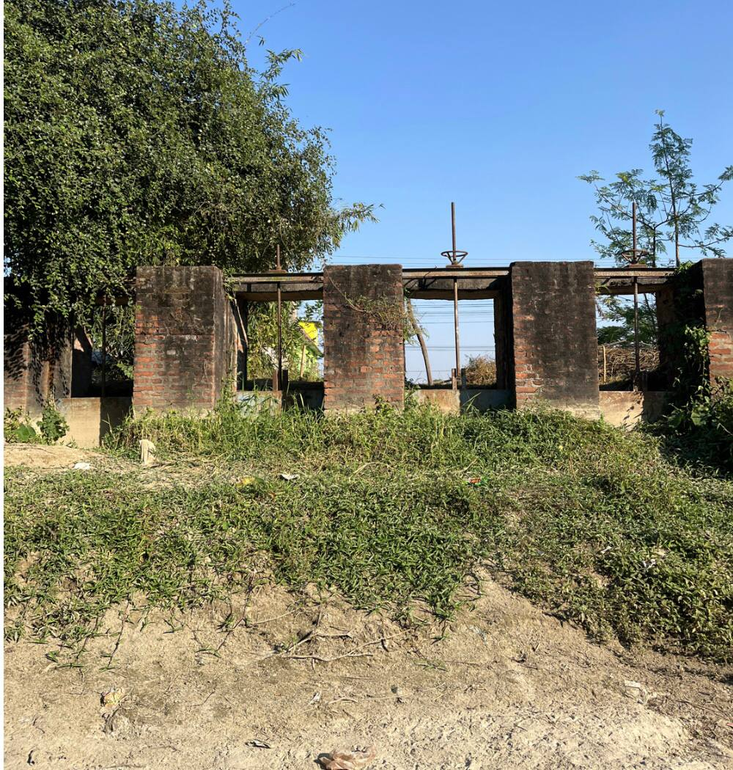  Escape, Vegetation growth  (Photo ID: MC012)
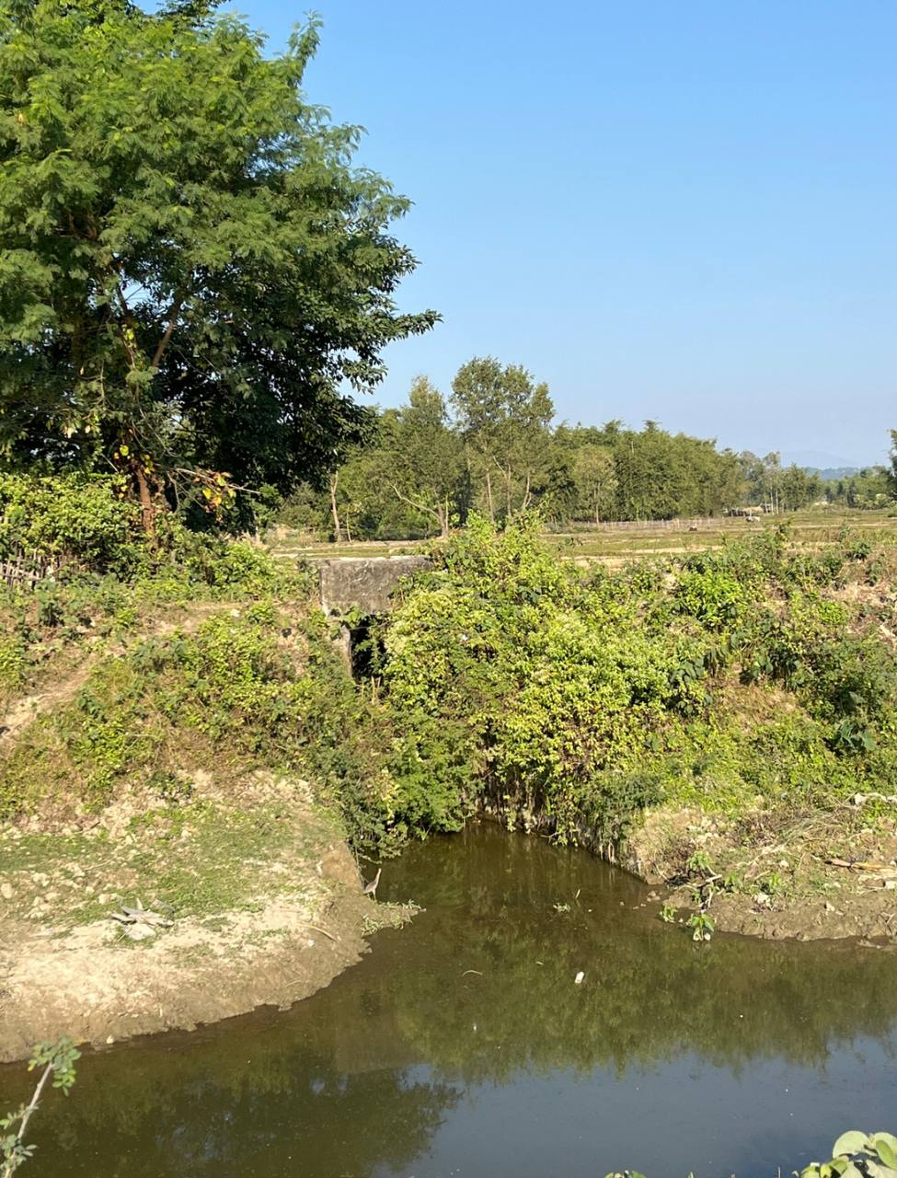  Drain Inlet, Vegetation growth  (Photo ID: MC051) | 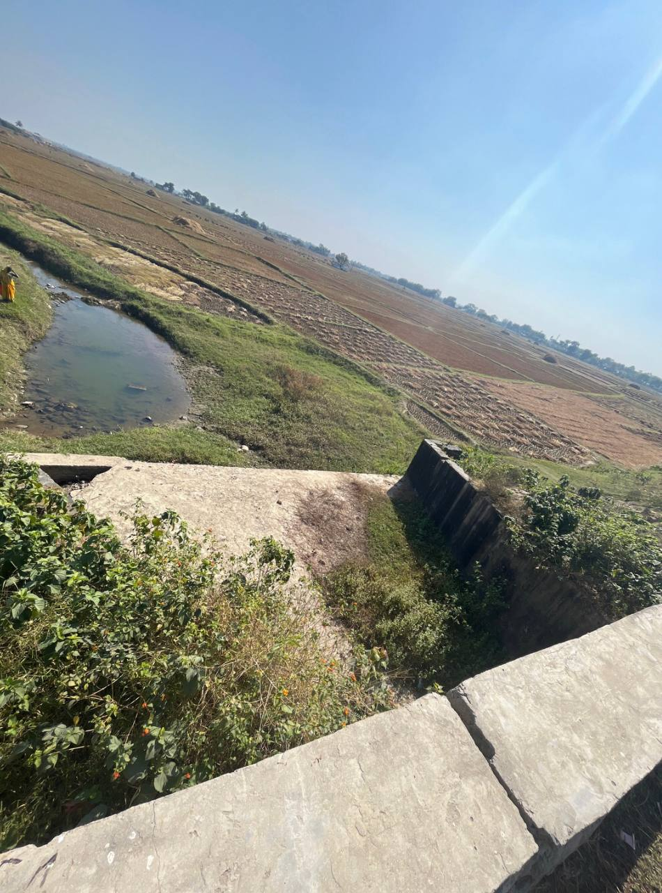  LD Syphon, Vegetation growth  (Photo ID: MC068)
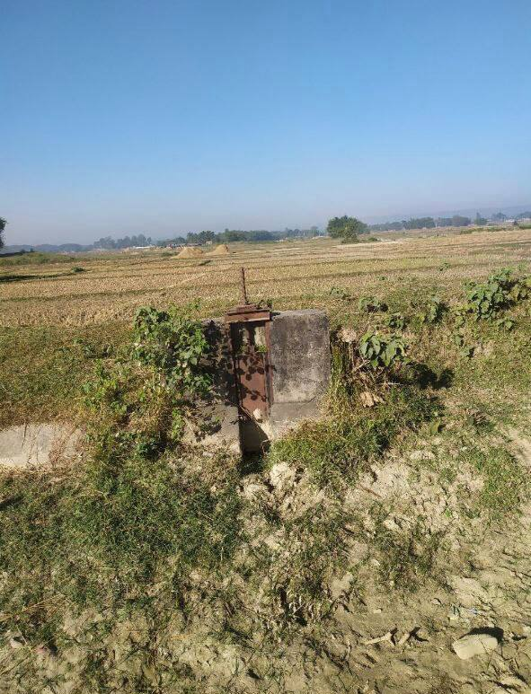  Right Outlet Vegetation growth  (Photo ID: OB040) | 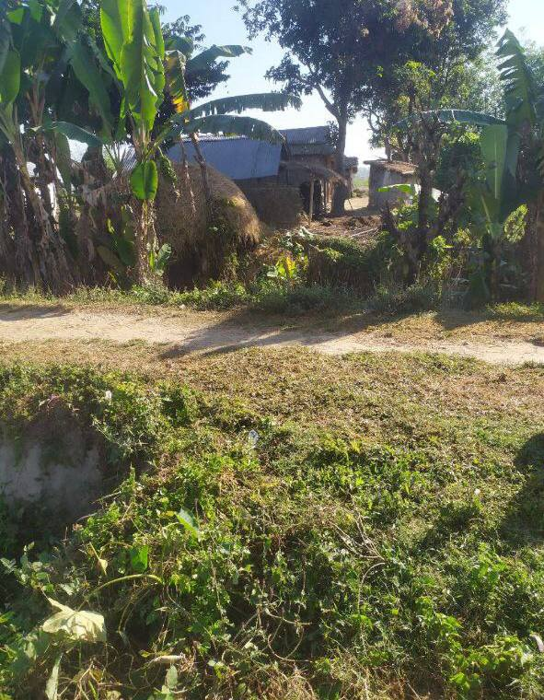  VRB, Vegetation growth  (Photo ID: OB055)
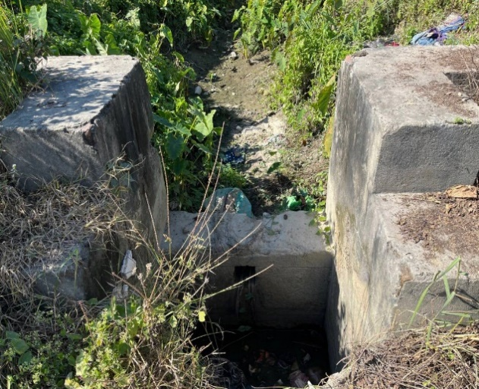  Fall, Vegetation growth  (Photo ID: KB004) | 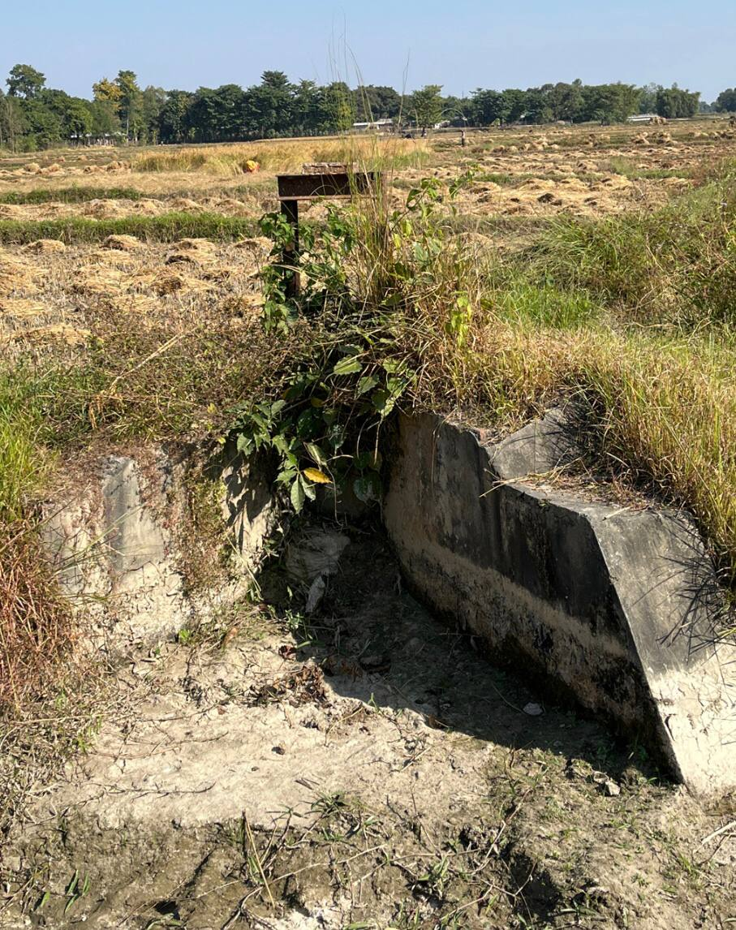  Outlet, Vegetation growth  (Photo ID: GB022)
Figure 5-5 : Weed and Vegetation growth in canal
Solution: Regular manual removal of weeds, using mechanical equipment or hand tools, can help keep vegetation in check. Additionally, applying environmentally safe herbicides or weed control products can be used strategically. Introducing natural enemies of weeds, such as herbivorous insects or bio herbicides, can also aid in biological control. To ensure long-term maintenance, it is crucial to conduct periodic inspections, promptly address any emerging weed issues, and implement preventive measures like the installation of geotextile fabrics to inhibit weed growth in the first place. Regular maintenance schedules, community involvement, and awareness programs can contribute to the sustained effectiveness of the weed control strategy.
Types: Annual/Seasonal
- Problem 6: Excess debris in surrounding area
Number of Problems encountered: 9
Possible Effects: Debris can obstruct the flow of water in the canal, leading to reduced conveyance capacity and increased risk of flooding during heavy rainfall. Debris can serve as a substrate for weed growth, exacerbating vegetation-related issues. The buildup of debris may contribute to sedimentation, altering the canal's morphology and reducing its overall efficiency. Moreover, debris can create a habitat for pests and disease vectors, posing environmental and health risks. To mitigate these effects, regular debris removal, proper waste management, and community awareness programs are essential components of canal maintenance and management.
Priority: Medium to High
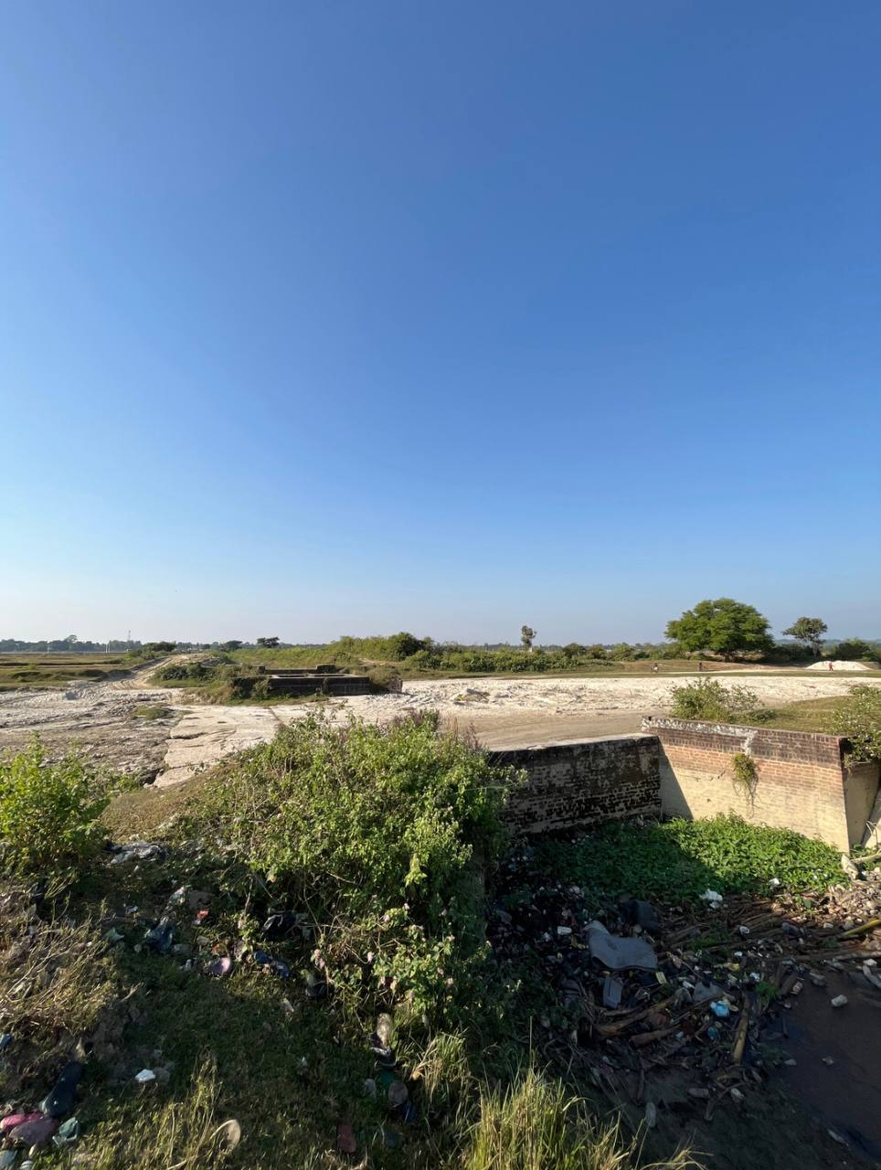  Syphon, Excess litter in surrounding area (Photo ID: MC055) | 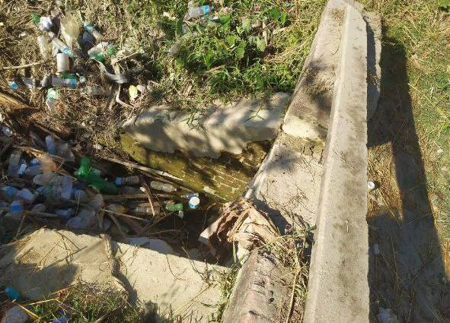  Fall, Excess litter in surrounding area, (Photo ID: OB051)
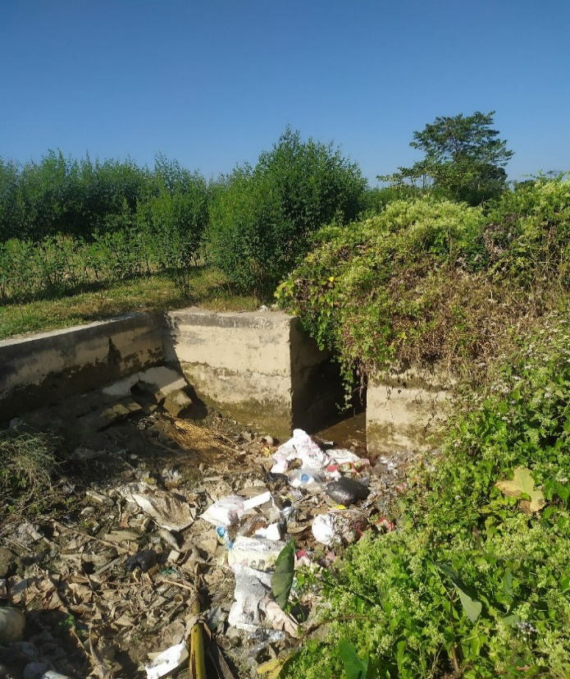  Fall, Excess litter in surrounding area  (Photo ID: MB008) | 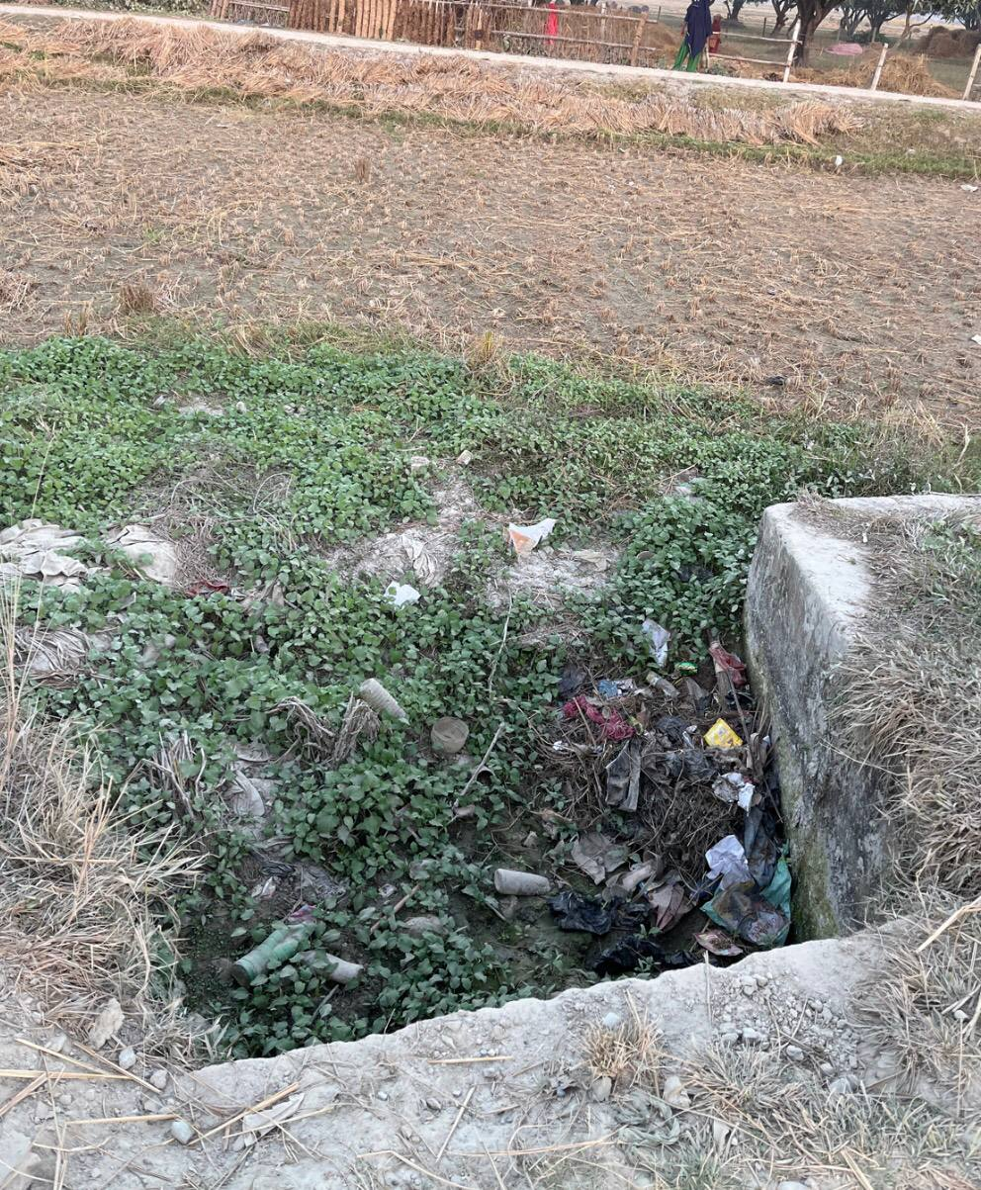  LD Syphon, Excess litter in surrounding (Photo ID: NH048)
Figure 5-6 : Excess debris in surrounding area of structures
Solution: Establish regular cleanup initiatives and community awareness programs to reduce debris input. Install trash racks or barriers to intercept floating debris, preventing its entry into the canal. Schedule routine maintenance for debris removal using appropriate equipment, and encourage sustainable landscaping practices to minimize debris production. Collaboration with local authorities and communities is essential for the success of these measures, ensuring a holistic and long-term solution to maintain a debris-free canal environment.
Types: Routine or annual/seasonal maintenance
- Problem 7: Clogged pipe
Number of Problems encountered: 13
Possible Effects: A clogged pipe in a canal structure can have significant detrimental effects. It impedes the flow of water, leading to reduced conveyance capacity and increased risk of flooding, particularly during heavy rainfall. This obstruction can also disrupt irrigation systems, impacting agricultural activities and potentially causing waterlogging in surrounding areas. Additionally, the accumulation of water behind the clogged pipe can lead to erosion and undermine the stability of the canal banks. Timely intervention is crucial to prevent these consequences, necessitating regular inspection and prompt removal of debris or obstructions in the pipes to ensure the efficient functioning of the canal system.
Priority: High to medium
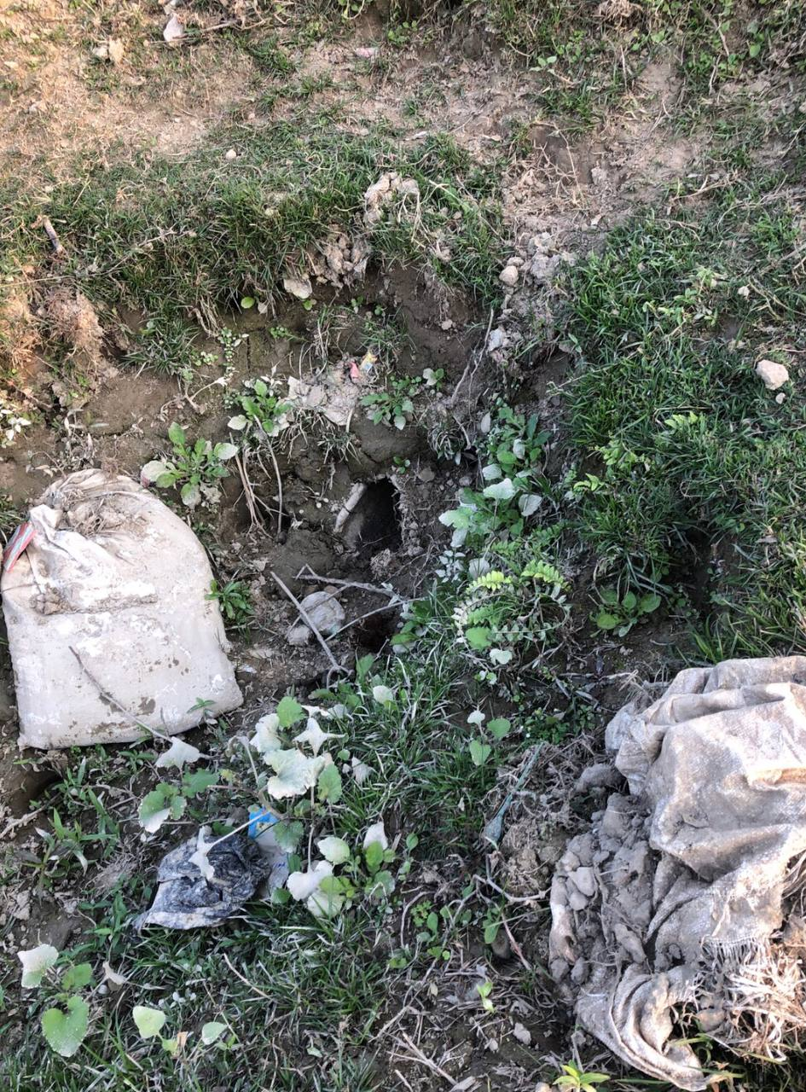  Clogged Pipe  (Photo ID: MC084) | 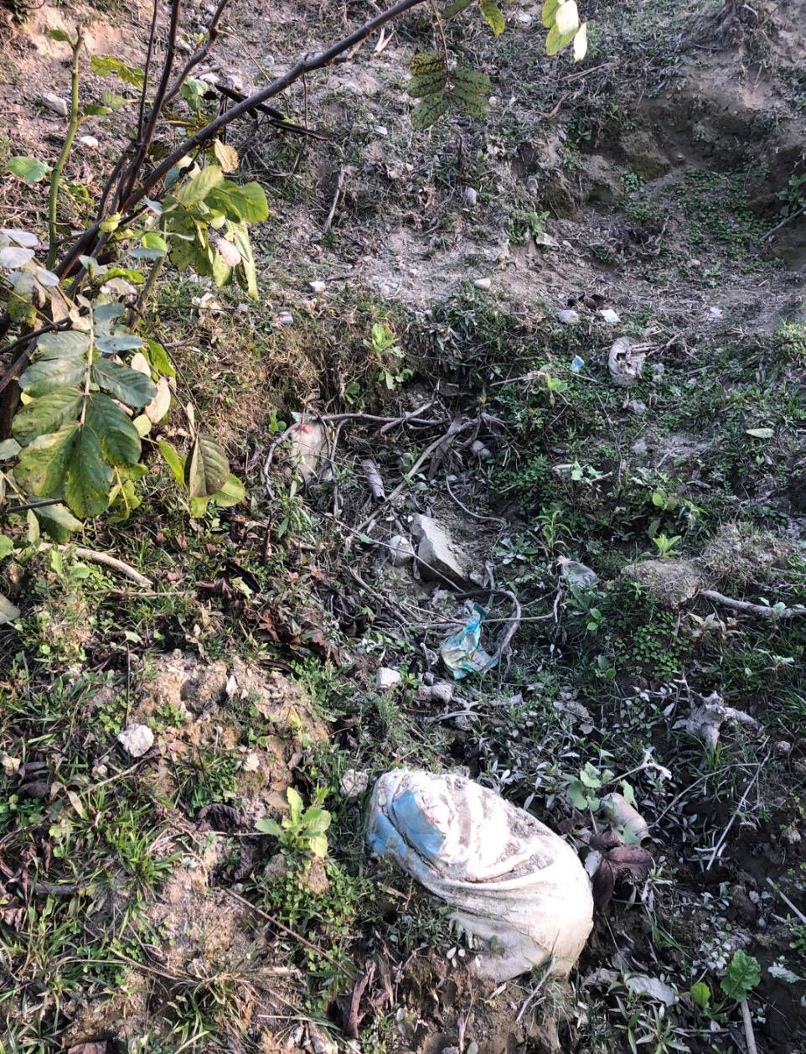  Direct Outlet Left, Clogged Pipe  (Photo ID: MC085)
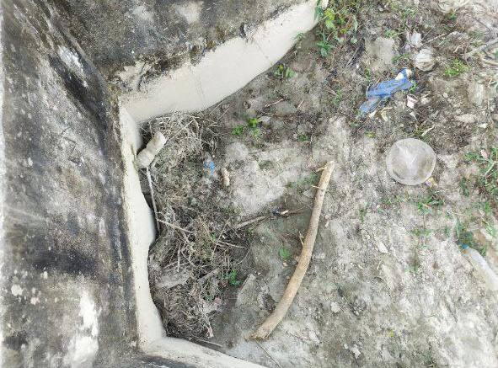  Left Outlet, Clogged Pipe  (Photo ID: OB028) | 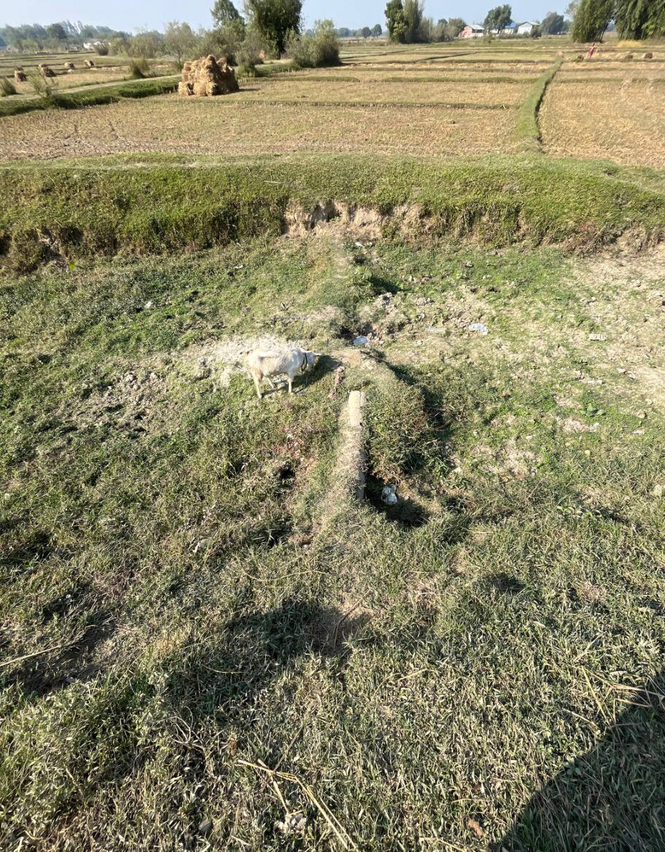  Left Outlet, Clogged Pipe  (Photo ID: OB030)
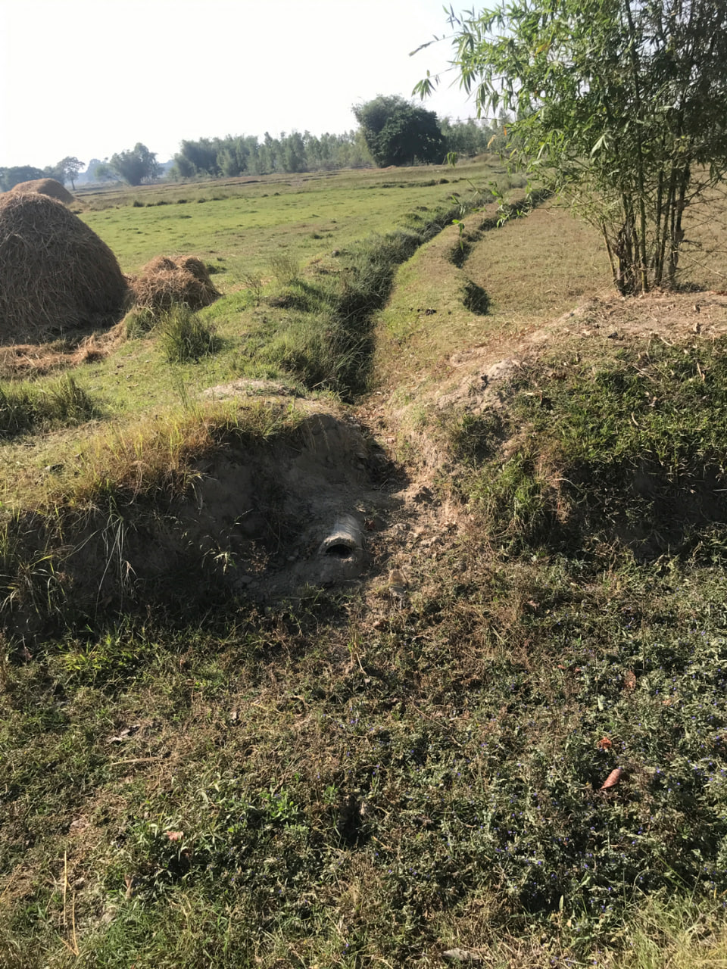  Right Outlet, Clogged Pipe  (Photo ID: BN021) | 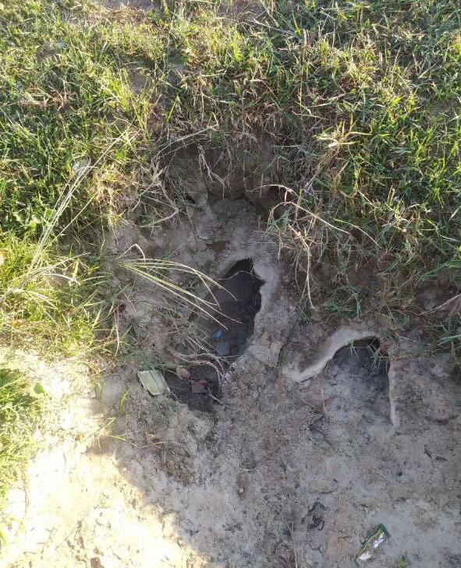  Left Outlet, Destroyed pipes  (Photo ID: OB018)
Figure 5-7 : Clogged pipes of different structures
Solution: Implementing debris screens or filters at pipe entrances can act as a first line of defense, reducing the likelihood of foreign materials entering the pipes. Scheduled cleaning routines to remove accumulated sediments and debris within the pipes. Additionally, community awareness programs can promote responsible waste disposal to minimize the introduction of debris into the canal system. Collaborative efforts with local authorities, regular monitoring, and swift response to identified issues are crucial components of an effective maintenance strategy to prevent and mitigate clogging in canal pipes.
Type: Annual and Seasonal Maintenance

Maintenance Tasks and Priorities
The maintenance of irrigation infrastructure is must for ensuring efficient water distribution and preventing potential hazards. Various sub-components of the CNIS require attention to address their potential issues. The problems encountered in the structures of CNIS are given priorities from P1 to P3 with the former being the highest requiring quick attention. The priority is given per the severity of damage the problem subjects to the stability and water delivery of the system.
As far as Main and Distributaries canal sections are concerned, breached banks pose a significant threat to the system, warranting the highest priority P1 due to the risk of flooding and structural instability. Damaged lining works in waterlogged areas are also of utmost priority for repair. Erosion and seepage along canal banks are critical problems demanding immediate attention with a priority P2. Channels with low banks, sedimentation, weed, and vegetation growth necessitate regular maintenance to avoid obstruction and ensure smooth water flow. Issues with canal lining works such as cracks, and weed growth require prompt intervention to maintain integrity (P2).
When the priority work comes to associated Canal Structures, Deteriorated cracks in structures, erosion in their vicinity, missing gates or stop logs and sedimentation problems require urgent attention and carry P1 priority. Regulators and outlets must be regularly checked for jammed gates, leaks, and corrosion. Fall and drop structures should be monitored for damage to crests, pipe barrels, and debris accumulation. Similarly, LD syphons, cross drainage culverts, and aqueducts require routine inspection and maintenance to prevent debris clogging, leakage, and structural damage, which fall under the P2 category if any. Prioritizing these maintenance tasks is crucial for ensuring the effective functioning of the irrigation system and mitigating potential risks. Table 5-2 includes all the maintenance problem and their associated priorities.
Table 5-2 : Prioritization table of different maintenance types
Component | Sub-Component | Possible Maintenance Problem | Priority
Main Canals, Distributaries and Minors |  | Breached Bank | P1
 |  | Erosion of canal banks. | P2
 |  | Seeping from canal banks. | P2
 | Channel | Low banks | P2
 |  | Sedimentation | P2
 |  | Weed and vegetation growth | P2
 |  | Need for sectioning | P2
 |  | Damaged in water logging area | P1
 | Canal lining | Damaged lining elsewhere | P2
 |  | Cracks and/or weed growth in lining | P2
 |  | Deteriorating cracks in structure. | P1
 |  | Deteriorating erosion downstream. | P1
 |  | Deteriorating seepage from structure. | P1
 | Most Structures | Trash or slit in front of structure. | P2
 |  | Cracks, seepage or damage to structure. | P2
 |  | Minor cracks (stable) or damage to structure. | P3
 |  | Minor vegetation in structure. | P3
 |  | Gate Missing | P1
 |  | Gate Spindle damaged or Missing | P1
 |  | Head or wing walls - Significant damage. | P2
 | Regulators/ Outlets | Gates Jammed or hard to operate | P2
 |  | Gate leaking | P2
 |  | Corrosion/rusting of steelwork. | P2
Canal Structures |  | Stop logs missing | P1
 | Fall/ Drop | Damage to crest. | P2
 |  | Damage to pipe barrel/drop section. | P2
 |  | Debris in drop section. | P2
 |  | Leakage from joints | P2
 |  | Damage to pipes/barrel. | P2
 | LD syphons/ Siphons | Debris in structure | P2
 |  | Clogged Pipe due to trash & silt | P2
 |  | Damage to inlet, outlet, drop structure | P2
 |  | Leakage from canal. | P2
 |  | Barrel damage. | P2
 | Cross drainage culverts | Debris in drain. | P2
 |  | Cracks in Canal lining | P3
 |  | Settlement/erosion/damage to piers | P1
 | Aqueducts | Leakage from joints | P2
 |  | Seepage from raised section | P2
 |  | Debris in flume | P2

Based on the problems as per above table, 670 structures associated with CNIS were subjected to prioritization based on those maintenance problems. 208 structures are given P1 priority and seek a quick response while 84 are subjected to P2 priority. The priority details per branches are included in Table 5-3. The prioritization of each structure is included in Annex 2 of this report in Volume II.
Table 5-3 : Number of structures based on prioritization types
Canal Category | Canal Name | P1 | P2 | P3 | Total
Main Canal | Main Canal | 33 | 21 | 17 | 71
Branch Canal | Odraha | 15 | 10 | 6 | 31
Branch Canal | Maleth |  | 2 | 1 | 3
Branch Canal | Baluwa | 13 | 2 | 1 | 16
Branch Canal | Kanchanpur | 10 | 3 | 1 | 14
Branch Canal | Old Hanumannagar | 2 | 3 | 2 | 7
Branch Canal | Barmajhiya | 9 | 5 | 4 | 18
Branch Canal | Barhara | 3 | 1 |  | 4
Branch Canal | New Hanumannagar | 27 | 10 | 1 | 38
Branch Canal | Goithi | 11 | 4 | 1 | 16
Branch Canal | Diman | 19 | 2 | 2 | 23
Branch Canal | Banauli | 25 | 7 | 2 | 34
Sub Branch | Akbarpur Kajauli | 9 | 9 | 4 | 22
Minor | Koladi | 8 |  | 3 | 11
Minor | Sakarapur | 6 |  | 1 | 7
Branch Canal | Sonra | 11 | 3 | 3 | 17
Sub Branch | Batnaha | 7 | 2 | 2 | 11
Grand Total |  | 208 | 84 | 51 | 343

Maintenance Scheduling

Effective maintenance scheduling for CNIS involves a regular inspection and timely repair of all irrigation components to ensure their optimal performance. This includes routine checks of Regulating structures, Gates, and pipe outlets to detect and address leaks, blockages, or wear and tear. The maintenance schedule of CNIS is proposed to cover the cleaning of filters and screens, installing erosion control structures, like riprap or gabions, headwall and other works.
A seasonal maintenance calendar is proposed that aligns with the irrigation cycle, ensuring that all critical tasks are completed before peak usage periods. Additionally, it is proposed to maintaining a detailed log of all maintenance activities and any issues encountered can help in predicting future problems. The Period of plan is 5 years where a partial maintenance activity shall be carried out each year in different phased. The yearly maintenance activities in CNIS is scheduled as in Table 5-4. It should be noted that no work is scheduled for the months of June and the days in between Feb-15 and March -15 due to the fact that irrigation water is to be supplied in this period.
Table 5-4 : Yearly maintenance scheduling of CNIS

CHAPTER 6: INSTITUTIONAL DEVELOPMENT PLAN

Proposed Institutional Organization Plan

Irrigation Agency
The CNIS Office Chief (first Class), who oversees the entire operation of the System, leads the existing organizational structure of the CNIS office. Directly under the Chief are two Senior Divisional Engineers (SDEs) – one specializing in Agro-irrigation (second Class) and the other in Civil engineering (2nd Class). These SDEs are responsible for coordinating the activities of Grade III Engineers in their respective fields. The Agro-irrigation division has two Grade III Engineers, while the Civil Engineering division has three. Supporting these engineers are Sub Engineers, with three focusing on civil engineering, two on mechanical, and one on electrical tasks. Additionally, there are two Accounting Officers managing the financial aspects. The operational team includes two Mechanics, three Electrical Operators, and four Pump Operators, ensuring the functionality and maintenance of irrigation systems. The support staff consists of four Helpers, three Office Helpers, and eleven Dhalpas, who assist with various office-related and on- field tasks. This hierarchical structure ensures efficient management and operation of irrigation projects within the CNIS.
S.N | Post | Grade | Service | Group | Num | Vac ant | Type
1 | Office Chief | G-I | Engineering | Agri- Irrigation | 1 |  | Permanent
2 | SDE | G-II | Engineering | Agri- Irrigation | 1 |  | Permanent
3 | SDE | G-II | Engineering | Civil | 2 | 1 | Permanent
4 | Engineer | G-III | Engineering | Agri- Irrigation | 2 |  | Permanent
5 | Engineer | G-III | Engineering | Civil | 2 |  | Permanent
6 | AO | NG-I | Administration | Accounting | 1 |  | Permanent
7 | Sub Engineer | NG-I | Engineering | Civil | 4 | 1 | Permanent
8 | Na. Su. | NG-I | Administration | General Admin | 1 |  | Permanent
9 | CAO | NG-I | Engineering | Agri- Irrigation | 1 |  | Permanent
10 | Sub Engineer | NG-I | Engineering | Electrical | 1 |  | Temporary
11 | Sub Engineer | NG-I | Engineering | Mechanical | 2 |  | P + T
12 | Senior Mechanics | NG-I | Engineering | Mechanical | 1 |  | Permanent
13 | Computer Operator | NG-I | Others |  | 1 |  | Temporary
14 | Surveyor | NG-I | Engineering | Survey | 0 |  | Permanent
15 | Mechanics | NG-II | Engineering | Mechanical | 2 |  | Temporary
16 | Electrical Operator | NG-II | Engineering | Electrical | 3 |  | Temporary
17 | Pump Operator | NG-II | Engineering | Mechanical | 4 |  | Temporary
18 | Helper |  | Engineering | Mechanical | 4 |  | Temporary
19 | Dhalpa |  | Engineering | Agri- Irrigation | 11 |  | Temporary
20 | Heavy Driver | No Grade | Engineering | Mechanical | 1 |  | Temporary
21 | Lightweight Driver | No Grade | Engineering | Mechanical | 2 |  | P + T
22 | Office Helper | No Grade | Administration | General Admin | 3 |  | P + 2T
 | Total |  |  |  | 50 | 2

Proposed expansion of the Institution aims to enhance system effectiveness. Currently, CNIS lacks a mechanical engineer. Therefore, recruiting one is essential to ensure efficient operation of pumps and related machinery. Responsibilities will encompass regular maintenance, troubleshooting mechanical issues, optimizing performance, and implementing enhancements. Additionally, overseeing equipment installation, ensuring safety compliance, and managing repairs of worn parts for continuous and effective irrigation are crucial tasks. Furthermore, a surveyor is needed for all survey-related activities. Vacancies for SDE and Civil Sub Engineer positions shall also be filled. The Proposed organizational structure is included in Figure 6-1.

CNIS Office Chief
1st Class
SDE
2nd class, Agro-irrigation
2 Numbers
SDE
2nd class, Civil
2 Numbers
Engineer
G-III, Agri-irrigation, 2 nos
Engineer
G-III, Mechanical, 1 Number
Engineer
G-III, Civil, 1 Number
Engineer
G-III, Civil, 1 number
Sub Engineer, Civil, 3 Number
Sub Engineer, Mechanical, 2 Number
Sub Engineer, Electrical, 1 Number
Accounting Officer, 2 Numbers
Senior Mechanic, 1 Number
Computer Operator, 1 Number
Na. Su., 1 Number
Surveyor, 1 number
Mechanics, 2 Numbers
Electrical Operator, 3 Numbers
Pump Operator, 4 Numbers
Helper, 4 Numbers
Office Helper, 3 Numbers
Dhalpa, 11 Numbers

Figure 6-1 : Proposed Organizational chart of CNIS

WUA Part
The WUA coordination committee of CNIS was formed and registered in the year 2055 B.S. under the Water Resources Act (1993). Currently, only the main committee is active for undergoing all WUA related work. The now setup for WUA is proposed in this report which consists of a WUA coordination committee at main canal level. Moreover, 12 WUA coordination committee at Distributary level is proposed for each distributary. Two WUA coordination committee for sub branches (Namely: Akbarpur Kajauli sub branch and Batnaha sub branch has been proposed. Therefore, a three-tiered organization is proposed, which are structured as follows:
WUA coordination Committee at Main Canal level (MCC) – 1 number, at least 30 members
WUA at Distributary level (DCC) – 19 members, 20 members
Sub branch Committee (SBC) level – 2 Numbers, 20 members
Figure 6-2 : Proposed WUA tier committee
WUA Co-ordination Committee for sub-branch
- Akbarpur, Kajauli
- Batnaha
Main WUA Co-ordination Committee
WUA Co-ordination Committee for each distributary
- Odraha
- Maleth
- Baluwa
- Kanchanpur
- Old Hanumannagar
- Barmajhiya
- Barhaha
- New Hanumannagar
- Goithi
- Banauli
- Diman
- Sonra

Additionally, the proposed WUA is tasked with various other roles and responsibilities, including:
- Acting as an interface between the farmers and the main system management.
- Justified Water distribution with less or no dispute.
- Operation and maintenance of the irrigation and drainage system.
- Collection (and assessment) of ISF and other user charges or special charges that the WUAs may levy.
- Resolution of local disputes amongst members
- Conflict resolution between members and nonmembers
- Design and construction of new works as well as rehabilitation of canals and structures
- Maintenance of commercial, financial and water accounting records

O&M Team Roles and Responsibilities
Roles of Agency:
- Responsible for the operation and maintenance of the CNIS headwork, main canal system, and their maintenance.
- Technical support to WUAs for operations and maintenance of branch canal system and all other canals of lower order.
- Preparation and update of manual on detailed system operation and maintenance and training to farmers.
Roles of Farmers/WUA:
- Responsible for the operation of branch and all other lower order canal system, operation and maintenance of branch, sub branch, minor and field channel level irrigation infrastructure and equipment
- Membership, and governance structure of WUAs
- Revenue collection through membership fee, irrigation service fee, machinery use fees etc.
- Choices of crops, seeds, and planting schedule
- Soil, fertilizer, and pesticide management
- Post-harvest management, and market activities
- Asset management that belongs to WUA and branch, sub branch, and minor canal level with clearly identified responsible person, asset inventory, asset management procedures
- Liaison with Agencies coordinator
- Irrigation scheduling including timing and duration of operations, rotational supply within the system if needed.

CHAPTER 7: RESOURCE MANAGEMENT PLAN

Existing System and Status of Collection
Since there is only one committee, it is responsible to collect the service fee and distribute as 80% to the CNIS office and 20% for their maintenance purposes. Proper records of the service fee collections are not available now, however the collected data indicated that certain portion of the service fee are collected and used for their regular maintenance. 5 years ago, in the fiscal year 2075/76 an amount rounding up to one lakh was collected. Same amount was collected in the year 2079/80, which suggests an average of one lakh is collected per years as ISF. The rate of the service fee is Nrs 2 per kattha per crop (Nrs 40 per Bigha, 20 Kattha = 1Bigha), which is quite insufficient to maintain the systems. It was also reported that the farmers contribute voluntary labor contribution for cleaning the canal in some branch canal, this works has not been counted in the service fee. At the initial period of the running of the canal, the farmers were enthusiastic to pay the service fee, but the collection works are not active from a decade.

Assessment of Service Fee Requirement to Match the O & M Cost
An assessment of the O&M cost for the CNIS office, headworks and main canal in one part and Branch, Sub branch and minor canal in another part was carried out at the present price. The estimated amount per ha are found as follows:
H/W, Main Canal, and CNIS office - NRs 2473/ha
Branch, Sub branch and Minor Canals - NRs 579/ha
The items of works considered are annual desilting of the canals, regular maintenance of the structures and river training works, and office expenditures.

Estimation of Annual O & M Costs
Chandra Nahar Irrigation system with a GCA of 12097 is a large irrigation system in Saptari district. It consists of diversion weir with under-sluice, main canal of 28 km, 12 number of branches, 2 sub branch and minor canals and 50 direct outlets from main canal. The annual O &M cost is estimated in consultation with officials of CNIS office, Rajbiraj based on their past practices. The Operation and Maintenance of Headwork, Main Canal, Building/ Equipment & Vehicle should to be done by the CNIS Office and lower level canal system by Water Users Committee.

- O & M BY CNIS OFFICE
- Headworks
The Table 7-1 outlines annual maintenance and operational activities associated with a headwork system of CNIS. Operating the headwork and the desilting basin is significantly more expensive, amounting to NRs. 600,000. Greasing works are broken down into specific tasks: greasing the intake gate costs NRs. 141,750, while greasing the scouring sluice gate costs NRs. 56,700. The manpower required for greasing or applying Mobil per gate is listed separately, with a cost of NRs. 10,237.
The supply and fitting of a thrust bearing involve two components: the material cost for the thrust bearing is NRs. 225,000, and the labor cost, calculated as 2.5% of the material cost, is NRs. 5,625. River channelisation work, aimed at managing the flow and course of the river, costs NRs. 200,000. Similarly, the structural protection of the headwork through river training work also incurs a cost of NRs. 200,000. Maintenance of cracks in the structure is estimated at NRs. 50,000. Finally, provision for emergency maintenance work is included, with a cost of NRs. 75,000. The total cost for all these activities sums up to NRs. 1,614,313. The data presented in this report have been sourced from Koshi Pump, chandra Nahar lrrigation Management Division office and in consultation with officials of Chandra Nahar Irrigation System. The detailed cost estimate is included in Volume II, Annex 1 of the report.
Table 7-1 : O & M costs under Headwork category
S.N. | Work Description | Amount (NRs.)
1 | Annual repair and maintenance of headwork | 50000
2 | Operation of headwork and desilting basin | 600000
3 | Greasing works
a | Intake gate | 141750
b | Scouring Sluice gate | 56700
4 | Manpower required for greasing/Mobil application per gate | 10237.5
5 | Supply and fitting of thrust bearing all complete
a | Material Thrust bearing | 225000
b | Labour cost, 2.5% of material cost | 5625
6 | River Channelisation work | 200000
7 | Headwork's Structural protection (River training work) | 200000
8 | Cracks maintenance | 50000
9 | Emergency maintenance work | 75000
 | Total | 1614313

- Main Canal
The Table 7-2 below provides a detailed breakdown of the operation and maintenance costs for the CNIS under the main canal category, with the total amounting to NRs. 2,454,201. The operation of HR/CR gates incurs a cost of NRs. 126,000. Greasing work is further divided into specific tasks: greasing the HR gate costs NRs. 45,360, the CR gate NRs. 52,920, and the escape gate NRs. 18,900. Mobil application costs are specified for different gates, with NRs. 6,314 for the CR gate, NRs. 18,040 for the HR gate, and NRs. 11,275 for the escape gate. Additionally, the manpower required for greasing or Mobil application per gate costs NRs. 6,825.
The supply and fitting of thrust bearings are detailed, with the material cost being NRs. 600,000 and the labor cost, at 2.5% of the material cost, amounting to NRs. 15,000. Providing and installing gate handles, including all related tasks such as cutting, welding, and transportation, costs NRs. 32,000. Similarly, the installation of MS shafts for gates incurs a cost of NRs. 20,000. Old shaft teeth facing, rethreading, and shaft bend straightening, including cutting, welding, and transportation, costs NRs. 14,000. Providing and installing nut bolts for gate servicing is estimated at NRs. 20,200. Structural protection work and drainage protection work each cost NRs. 120,000. Desilting and canal bank repair in the unlined canal section is a significant expense at NRs. 990,500. The construction of an office building at the main canal costs NRs. 120,000, and provision for emergency maintenance work amounts to NRs. 116,867. The detailed cost estimate is included in Volume II, Annex 1 of the report.
Table 7-2 : O & M costs under Main Canal category
S.N. | Work Description | Amount (NRs.)
1 | Operation of HR/CR | 126000
2 | Greasing Work
a | HR gate | 45360
b | CR Gate | 52920
c | Escape gate | 18900
3 | Mobil Application for
a | CR Gate | 6314
b | HR gate | 18040
c | Escape gate | 11275
d | Manpower required for greasing/Mobil application per gate | 6825
4 | Supply and fitting of thrust bearing all complete
5 | Material Thrust bearing | 600000
a | Labour cost, 2.5% of material cost | 15000
b | Providing and installation of gate handle for gate including cutting, welding, transportation all complete | 32000
6 | Providing and installation of MS shaft for gate including cutting, welding, transportation all complete | 20000
7 | Old shat teeth facing and rethreading, shaft bend straighten for gate including cutting, welding, transportation all complete | 14000
8 | Providing and installation of nutbolts for gate servicing | 20200
9 | Structural protection work | 120000
10 | Drainage protection Work | 120000
11 | Desilting and canal bank repair in the unlined canal section | 990500
12 | office building @ main canal | 120000
13 | Emergency maintenance work | 116867
 | Total | 2454201

- Building Equipment and Vehicle cost
The Table 7-3 delineates the operation and maintenance costs associated with vehicles and buildings of the Chandra Nahar Irrigation System, summing to a total of NRs. 3,833,214. The average cost for building maintenance is NRs. 32,500. The maintenance expenses for equipment and vehicles are broken down as follows: NRs. 80,000 for motorcycles, NRs. 600,000 for jeeps or pickups, and NRs. 1,000,000 for excavators. An additional provision for emergency maintenance costs NRs. 182,534.
This comprehensive breakdown ensures a thorough understanding of the financial requirements for maintaining the operational efficiency of both the vehicles and buildings for the Chandra Nahar Irrigation System. The detailed cost estimate is included in Volume II, Annex 1 of the report.
Table 7-3 : O & M costs for Building, Equipment and Vehicles
S.N. | Work Description | Amount (NRs.)
1 | Building maintenance (average) | 32500
2 | Equipment/vehicle maintenance
a | Motor-Cycle | 80000
b | Jeep / Pickup | 600000
c | Excavators | 1000000
d | Emergency maintenance | 182534  4
3 | Equipment/vehicle Fuel Cost
a | Motor-Cycle | 128880
b | Jeep / Pickup | 682560
c | Excavators | 834240
 | Total | 3833214

- Operation Cost
The Table 7-4 outlines the annual operation costs for the Chandra Nahar Irrigation System, totaling NRs. 22,015,500. This includes the remuneration for various office staff and overhead costs. The remuneration for staff is divided into several categories: First Class Officers receive NRs. 871,000, Second Class Officers are paid NRs. 1,352,000, and Third Class Officers are paid NRs. 1,833,000 in total throughout the year. Non-Gazetted First Class employees receive NRs. 3,640,000, while Non-Gazetted Second Class employees are paid NRs. 1,248,000. Support staff earn NRs. 1,950,000, drivers receive NRs. 780,000, and the Dhalpa category is allocated NRs. 3,003,000. The overhead cost for office operations is NRs. 7,338,500 which is 50% of office operation cost.
Table 7-4 : Annual Operation cost for CNIS
S.N. | Work Description | Nos. | Rate | Amount (NRs.)
1 | Remuneration of Office staff
a | First Class Officer | 1 | 67000 | 871000
b | Second Class Officer | 2 | 52000 | 1352000
c | Third Class officer | 3 | 47000 | 1833000
d | Non Gazette First | 8 | 35000 | 3640000
e | Non Gazette Second | 3 | 32000 | 1248000
f | Support Staff | 6 | 25000 | 1950000
g | Driver | 2 | 30000 | 780000
h | Dhalpa | 11 | 21000 | 3003000
2 | Overhead cost for office operation | 1 |  | 7338500
 | Total |  |  | 22015500

- Total Cost by Office Part
The total cost for the office part is the sum of expenses related to Headwork, the Main canal, Building Equipment and Vehicles, and Operation costs for CNIS, as detailed in earlier sections. The CNIS serves a Gross Command Area (GCA) of 12,097 hectares, and the total Maintenance, Operation, and Management (MOM) cost for the agency part is estimated to be NRs. 29,917,227. Therefore, the MOM cost per hectare for CNIS is estimated to be NRs. 2,473.
Total MOM Cost Agency = Nrs. 29,917,227
Total area in ha served by System = 12,097 Ha
MOM Cost/ha = NRs. 2,473

- O & M BY WATER USERS COMMITTEE/ASSOCIATION
- Branch/Sub branch/Minor Canal
The Table 7-5 below provides a comprehensive overview of the operation and maintenance (O&M) costs for branches, sub-branches, and minor canals managed by the Water Users Committee/Association, with a total expenditure of NRs. 2,554,063. The costs are categorized into various maintenance activities essential for the effective functioning of the irrigation system.
The operation of HR/CR gates incurs a cost of NRs. 29,500. Greasing work is detailed further: greasing the HR gate costs NRs. 9,450, the CR gate NRs. 11,340, and the escape gate NRs. 1,890. Mobil application costs are specified for different gates, with NRs. 3,608 for the CR gate, NRs. 4,510 for the HR gate, and NRs. 902 for the escape gate. Additionally, manpower required for greasing or Mobil application per gate costs NRs. 4,641. The supply and fitting of thrust bearings are detailed with the material cost being NRs. 150,000 and the labor cost, calculated at 2.5% of the material cost, amounting to NRs. 3,750. Providing and installing gate handles, including cutting, welding, and transportation, costs NRs. 8,000. Similarly, the installation of MS shafts for gates incurs a cost of NRs. 2,500. Old shaft teeth facing, rethreading, and shaft bend straightening, including cutting, welding, and transportation, also costs NRs. 2,500. Providing and installing nut bolts for gate servicing is estimated at NRs. 5,850.
Structural protection work and drainage protection work each cost NRs. 120,000. Desilting and canal bank repair in the lined canal section costs NRs. 54,000, while the same work in the unlined canal section is a significant expense at NRs. 1,750,000. Emergency maintenance work costs NRs. 121,622, cracks repair is estimated at NRs. 50,000, and canal backside refilling work costs NRs. 100,000. The detailed cost estimate is included in Volume II, Annex 1 of the report.
Table 7-5 : Total O & M costs for Branches, Sub Branches and minors
S.N | Work Description | Amount (Nrs.)
1 | Operation of HR/CR | 29500
2 | Greasing Work
a | HR gate | 9450
b | CR Gate | 11340
c | Escape gate | 1890
3 | Mobil Application for
a | CR Gate | 3608
b | HR gate | 4510
c | Escape gate | 902
4 | Manpower required for greasing/Mobil application per gate | 4641
5 | Supply and fitting of thrust bearing all complete
a | Material Thrust bearing | 150000
b | Labour cost, 2.5% of material cost | 3750
6 | Providing and installation of gate handle for gate including cutting, welding, transportation all complete | 8000
7 | Providing and installation of MS shaft for gate including cutting, welding, transportation all complete | 2500
8 | Old shat teeth facing and rethreading, shaft bend straighten for gate including cutting, welding, transportation all complete | 2500
9 | Providing and installation of nutbolts for gate servicing | 5850
10 | Structural protection work | 120000
11 | Drainage protection Work | 120000
12 | Desilting and canal bank repair in the lined canal section | 54000
13 | Desilting and canal bank repair in the unlined canal section | 1750000
14 | Emergency maintenance work | 121622
15 | Cracks repair | 50000
16 | Canal Back-side refilling work | 100000
 |  | 2554,063

- Building, Equipment and Machineries
The Table 7-6 outlines the operation and maintenance costs for buildings, equipment, and machineries under the Water Users Association (WUA), totaling NRs. 226,800. The average cost for building maintenance is NRs. 80,000. Maintenance expenses for equipment and vehicles include NRs. 40,000 for motorcycles, NRs. 12,000 for cycles, and an additional NRs. 30,000 allocated for emergency maintenance. Fuel costs for motorcycles amount to NRs. 64,800. The detailed cost estimate is included in Volume II, Annex 1 of the report.
Table 7-6 : Building, Equipment and Machineries cost for WUA
S.N. | Work Description | Amount (NRs.)
1 | Building maintenance (average) | 80000
2 | Equipment/vehicle maintenance
a | Motor-Cycle | 40000
b | Cycle | 12000
c | Emergency maintenance | 30000
3 | Equipment/vehicle Fuel Cost
a | Motor-Cycle | 64800
 | Total | 226,800

- Operation Cost
Table 7-7 presents the annual operation costs for the Water Users Association (WUA), amounting to NRs. 4,224,000. This includes the remuneration of office staff, logistic expenditure, and rent. The remuneration for office staff encompasses NRs. 540,000 for an accountant or office assistant, and NRs. 1,728,000 for branch support staff, sub-branch support staff, support staff for minor canals, and logistic expenditure rent. Specifically, sub-branch support staff are allocated NRs. 45,000, while support staff for minor canals receive NRs. 96,000. Logistic expenditure is estimated at NRs. 180,000, and rent costs are substantial, totaling NRs. 1,440,000.
Table 7-7 : Annual Operation costs for WUA
S.N. | Work Description | Amount (NRs.)
1 | Remuneration of Office staff
a | Accountant/Office assistant | 540000
b | Branch Support Staff  Sub Branch support staff  Support staff for minor canal  Logistic expenditure  Rent | 1728000
c | Sub Branch support staff | 45000
d | Support staff for minor canal | 96000
2 | Logistic expenditure | 180000
3 | Rent | 1440000
 | Total | 4224000

- Total Cost by WUA part
The total cost for the WUA part is the sum of expenses related to Branches,Subbranches and Minor Canal, Building Equipment and Machineries, and Operation costs for WUA, as detailed in earlier sections. The CNIS serves a Gross Command Area (GCA) of 12,097 hectares, and the total Maintenance, Operation, and Management (MOM) cost for the agency part is estimated to be NRs. 7,004,863. Therefore, the MOM cost per hectare for CNIS is estimated to be NRs. 579/ha.
Total MOM Cost of WUA = Nrs. 7,004,863
Total area in ha served by System = 12,097 ha
MOM Cost/ha = 579

Deferred Maintenance Costs
Deferred maintenance refers to the postponement of maintenance activities such as repairs on irrigation infrastrucutres, typically due to budget constraints. The table provided outlines the deferred maintenance costs for the Chandra Nahar irrigation system. These are basically the costs required for the upgradation of structure in terms of their performance enhancement. The performance rating of the low rated structures (1, 2 and 3) is expected to increase to higher rating (4 and 5) after performing this maintenance activity.The associated costs are substantial, amounting to a grand total of 17,613,891 Nrs. The costs cover various maintenance works including bank protection (2,640,000 Nrs.), clearance works (26,500 Nrs.), crack repair activities (135,600 Nrs.), and crest replacement (80,000 Nrs.). Significant expenses include footbridge construction (4,000,000 Nrs.) and gate replacement (4,025,000 Nrs.). Other notable costs involve gate spindle replacement (1,321,795 Nrs.), lining works (6,000,000 Nrs.), and replacement of VRB (3,140,534 Nrs.). Additional maintenance tasks include outlet and pipe replacements, reconstructing guardrails, and wing wall construction.
Table 7-8 : Deferred Maintenance cost of CNIS
Maintenance Works | Associated cost (Nrs.)
Bank Protection Works | 2,640,000
Clearance works | 26,500
Crack Repairment activities | 135,600
Crest Replacement Work | 80,000
Footbridge Construction | 4,000,000
Gate Replacement | 4,025,000
Gate Spindle Replacement | 1,321,795
Lining Works | 6,00,000
Outlet Repalcement | 100,000
Pipe Clearance works | 13,500
Pipe Replacement | 120,000
Reconstruct Guardrails | 435,030
Replacement of Fall | 750,932
Replacement of Outlet | 200,000
Replacement of VRB | 3,140,534
Wing wall Construction | 25,000
Grand Total | 17,613,891

(Source: Modified from detailed engineering survey, design and cost estimate for the renovation and rehabilitation of chandra canal system Report, 2023)

Resource Management Plan
The above sections illustrated the requirements of expenditure budget for regular operation & maintenance, and deferred maintenance for the whole system. It has been proposed that the deferred maintenance works will be carried out by the CNIS office with their own funding resources. The budget required for the regular operation and maintenance of branch, sub branch and minor canals would be managed by the WUAs with their own possible resources. The tasks of the deferred maintenance works might continue beyond the project period based on the government’s allocation for the works. To meet these requirements of funds the WUA must know how it will get the resources and how it is going to manage it. Several sources of income could be recognized from the irrigation system as follows:
- Irrigation service fee as the main component for its sustainability.
- Transport charges levied for the use of the service road of the canals.
- Membership Fee
- Penalty from the defaulters,
- Kind contribution by the beneficiaries,
- Subsidy from the government.
Among these resources, the irrigation service fee and the kind contribution by the beneficiaries are the prime resources for the funding resources. Total cost for operation and maintenance of the branch and sub branch system has been estimated as Nrs 579 per ha on the WUA’s part. Excluding the desilting part of the activities other expenditures work out to be Nrs 430 per ha. However, this desilting activity also is vital in running the system so proper recordings also have to be made for this works. The total man-days spent for this activity should be recorded to evaluate the kind contribution of the beneficiaries. It is envisaged that the farmers will pay in cash for the service fee and in addition, some kind contributions have to be made to meet the O&M requirements. Therefore, the WUA of the system must be transparent and updated with the records of each beneficiary with their contributions in cash as well as in kind. Reliability and authenticity of the WUA’s work performance will indicate the success and failure of the system turnover. The records must be updated with the financial as well as administrative records regarding the contribution of the farmer; it will convince the users on their organization. It is planned that the WUA will be able to recover full O&M requirements within five years’ period. Until such time the government will have to give subsidy to the organization for maintaining the required expenditure of O&M. Tentative estimate of the budget requirements and resource generation has been prepared for the CNIS system on the O&M part of the branch and lower canal systems. The following table depicts the resource mobilization plan for the WUA in the operation and maintenance of the branch, sub branch and minor canal system; in addition, the operation of the main canal structures also comes under its jurisdiction. The table of the resource management has been prepared based on the data and total annual requirement of about Nrs 7004863.
Table 7-9 : Resource Mobilization Plan for WUA
Year | Financial Resources | Anticipated Amount (Nrs) | Proposed Budget Allocation (Nrs)
 |  |  | WUA Part | Subsidy from DOI | Total Proposed Budget
1st | Service Fee @ Nrs 100 per ha | 900,000 | 720,000
 | Taxes on Service Roads and others | 30,000 | 30,000
 | Membership Fee @ Nrs 10 per HH/year | 170,000 | 170,000
 | Kind Contribution on desilting works (5280 man-days) | 633,600 | 633,600
 | Sub-total 1st year | 1,733,600 | 1,553,600 | 3,000,000 | 4,553,600
2nd | Service Fee @ Nrs 200 per ha | 1,800,000 | 1,440,000
 | Taxes on Service Roads and others | 50,000 | 50,000
 | Membership Fee @ Nrs 10 per HH/year | 170,000 | 170,000
 | Kind Contribution on desilting works (10,000 man-days) | 1,200,000 | 1,200,000
 | Sub-total 2nd year | 3,220,000 | 2,860,000 | 2,000,000 | 4,860,000
3rd | Service Fee @ Nrs 300 per ha | 2,700,000 | 2,160,000
 | Taxes on Service Roads and others | 70,000 | 70,000
 | Membership Fee @ Nrs 10 per HH/year | 170,000 | 170,000
 | Kind Contribution on desilting works (16,500 man-days) | 1,980,000 | 1,980,000
 | Sub-total 3rd year | 4,920,000 | 4,380,000 | 600,000 | 4,980,000
4th | Service Fee @ Nrs 400 per ha | 3,600,000 | 2,880,000
 | Taxes on Service Roads and others | 80,000 | 80,000
 | Membership Fee @ Nrs 10 per HH/year | 170,000 | 170,000
 | Kind Contribution on desilting works (16500 man-days) | 1,980,000 | 1,980,000
 | Sub-total 4th year | 5,830,000 | 5,110,000 | 500,000 | 5,610,000
5th | Service Fee @ Nrs 470 per ha | 4230000 | 3,384,000
 | Taxes on Service Roads and others | 90000 | 80,000
 | Membership Fee @ Nrs 10 per HH/year | 170000 | 170,000
 | Kind Contribution on desilting works (16500 man-days) | 1,980,000 | 1,980,000
 | Sub-total 5th year | 6,470,000 | 5,614,000 | - | 5,614,000

The subsidy to the WUA for running the systems will be phased out in four years. It is anticipated that the recovery will be made during the period with full control of the WUA. At this state the beneficiary has to pay Nrs 470 per ha as irrigation service fee, plus kind contribution of about 0.5 man-days per year (Total HH 35000, total Man-days required is 16500).

CHAPTER 8: MONITORING AND EVALUATION PLAN
Effective monitoring and evaluation (M&E) are essential components of the asset management strategy for an irrigation system. The M&E Plan provides a structured approach to track the implementation and performance of the system, ensuring that objectives are met, resources are used efficiently, and improvements are continuously identified and implemented.
The M&E framework for the irrigation system encompasses key components, including implementation monitoring and impact evaluation. Each component plays a crucial role in maintaining the system's functionality and achieving the long-term goals outlined in the Asset Management Plan (AMP).

Implementation Monitoring
Implementation Monitoring focuses on tracking the progress of asset management activities and ensuring that they are executed as planned. Monitoring within the Chandra Nahar Irrigation Systems entails the systematic collection and analysis of information aimed at enhancing the effectiveness of maintenance operations. Regular monitoring, overseen by higher authorities, serves to promptly identify actual or potential issues and deviations from the approved maintenance plan. This proactive approach allows for timely adjustments in implementation to ensure smooth operation of the irrigation system. Effective monitoring is integral to managing construction and maintenance projects, ensuring adherence to standards and optimizing resource allocation.

8.1.1 Performance Monitoring
Performance monitoring is essential for reviewing maintenance planning processes to verify their alignment with system requirements and to address any discrepancies promptly. Given the complex nature of maintenance activities involving multiple entities and concurrent tasks, performance monitoring serves as a vital tool for maintaining operational efficiency. Benefits include site-specific problem-solving, providing diverse perspectives to site engineers, and preemptively addressing issues before they escalate. To maintain effectiveness, performance monitoring is conducted at least annually by senior engineers from within the Department of Water Resources and Irrigation (DWRI). These engineers possess the expertise to identify and rectify any operational inconsistencies.

Maintenance Log
Each fiscal year's maintenance activities of CNIS are continuously recorded in a maintenance log, which serves as a comprehensive record of asset maintenance. This log includes details such as asset locations, associated canal, year of maintenance, and specific tasks and activities undertaken and details of responsible log keeper. This provides critical information for asset inspections and enables decision-makers to assess maintenance trends and plan future activities effectively. By critically analyzing entries in the maintenance log, decision-makers can proactively implement precautions and optimize maintenance strategies to enhance the longevity and performance of the irrigation system.
Table 8-1 : Maintenance log sample
System Name:
Name of Canal:
Date | Name of Structure | Location | Activities | Name of Log Keeper | Signature of Log Keeper
Sample
5/2/2024 | Measuring Structure | 0+500 | Gauge plate replaced
5/3/2024 | Cross Regulator | 0+750 | Rubber seal replaced
5/4/2024 | Main Canal Service road | 0+100 | Patch repair

Impact Evaluation

Enhancing Agricultural Productivity and Economic Benefits
Impact Evaluation for the Chandra Nahar Irrigation Systems is dedicated to evaluating how the system enhances agricultural productivity and fosters economic benefits. This assessment involves rigorous measurements of crop yields before and after the implementation of irrigation improvements, aiming to quantify the direct impact of enhanced water delivery systems on agricultural outputs. Additionally, the evaluation scrutinizes water use efficiency to determine how effectively resources are managed in relation to crop production, thereby identifying opportunities for further optimization. Economically, the assessment delves into analyzing the tangible benefits experienced by local farmers and the broader community. This includes assessing changes in farm income and profitability resulting from improved irrigation practices, as well as quantifying cost savings associated with more efficient water usage and irrigation techniques. By thoroughly examining these aspects, decision-makers gain insights into the economic viability and sustainability of ongoing irrigation system improvements, guiding future resource allocation and policy decisions.

Assessing Social and Community Impacts
In the context of the Chandra Nahar Irrigation Systems, assessing social and community impacts is essential for understanding the broader benefits and challenges associated with the infrastructure. This part of the evaluation involves gathering comprehensive feedback from community members to gauge their perceptions of the irrigation system's benefits and any challenges it may pose. It explores how the system contributes to social cohesion, local livelihoods, and overall community well-being. By systematically analyzing these social impacts, decision-makers can identify ways to strengthen community engagement, address potential issues, and maximize the positive socio-economic outcomes of the irrigation system. This holistic approach ensures that the Chandra Nahar Irrigation Systems not only support agricultural productivity but also contribute positively to the socio-economic fabric of the region, fostering sustainable development and resilience.

CHAPTER 9: CONCLUSIONS AND RECOMMENDATIONS
This report primarily focused on the assessment of present condition of the assets associated with Chandra Nahar irrigation system. The performance rating for each asset was assigned based on their functionality. The possible remedies of the problem they carry were analysed and the tentative cost they desire for proper functioning are estimated. Cost pertaining to the deferred maintenance of the system was also estimated which suggests a total of NRs. 17,613,891 is required for this maintenance activity.
Moreover, the maintenance activities to be performed for various problems associated with each individual structure of CNIS are discussed in this report. The responsible authority for the execution of this maintenance activity is assigned and their roles and responsibilities too. Risk assessment is done for all the vulnerable structures and Priorities are given to their problems based on the severity they carry to water distribution and structural stability.
The MOM cost for the system is estimated in 2 interfaces, one as Office part and other being the WUA part. The Operational cost for Office part is estimated to be Nrs. 2,473/ha whereas that of WUA part as Nrs. 579/ha. This report plans to handover the Branch and lower order canals to WUA which will in turn become a self-sustaining association after 5 years. Hence, the Asset Management Plan has been prepared to focus on the sharing of responsibility between WUA and CNIS. The WUA’s on their part will have to be active and strong enough to take care of the system operate and maintain it diligently to cover maximum area under irrigation. It is anticipated that this AMP report will support and strengthen WUA to bring their capacity up to the required level. It is aimed to make the WUA organization as self-governing, self-regulating, and self-financing sustainable institution. Summarizing the recommendations, the following points could be made:
- The farmers must be convinced that the contribution of 4 to 5 percent of their gross income is sufficient to cover their O & M cost of their system, which is reasonable and long lasting (Nrs. 579 per ha from the gross income of Nrs. 30,000 to 50,000 per ha annually;

- It is proposed that the WUA should be made more responsive and active to collect ISF. The enforcement of rules and water distribution schedule could be applied by this organization more efficiently;
- In order to monitor the function of WUA’s and CNIS office, it is recommended to form an ad hoc committee from the users as independent evaluators of the performances of WUA and CNIS activities.
- Yearly update on AMP is suggested so as to account for the increment in O & M cost as well as associated cost of Deferred Maintenance

